Assessment Plan
for
M.S. in Electrical and Computer Engineering Program, and
M.S. in Systems Engineering Program

Department of Electrical and Computer Engineering
School of Engineering and Computer Science
Oakland University

1.0 An Overview of ECE Department’s Assessment Process

The faculty of the department of Electrical and Computer Engineering (ECE) are committed to continuously improve the quality of both the undergraduate and graduate educational programs. The faculty has developed and implemented a formal plan to measure, assess, evaluate and improve the ECE programs in a systematic way. The development of this plan began with identifying the constituent groups the ECE department serves, that is, students, employers and faculty; setting outcomes for each educational program that describe the skills necessary for successful modern engineering practice; and identifying outcomes for each educational program that insure the skills necessary to achieve the program learning outcomes.
The program assessment/improvement process involves both indirect and direct measures of the success of each course within each program as well as overall measures of the educational programs and of the assessment process itself. The overall success of a program is measured by whether the students of that program can demonstrate achievement of all outcomes as they graduate.

The ECE department administers two Master of Science (MS) programs, namely, MS in Electrical and computer Engineering (MSECE) and MS in Systems Engineering (MSSE). Since these two programs are intertwined, the ECE department faculty have chosen a common, embedded approach to the assessment of these programs. Key courses have been identified in both programs, where students have the opportunity to demonstrate the achievement of the program outcomes; the set of key courses is chosen to insure that all of the program outcomes are demonstrated. Student materials are collected from the key courses that provide evidence that the outcomes have been achieved. External evaluators, including faculty not directly involved with the course and departmental advisory board members, review these materials to establish whether the students in that class have achieved some or all of the program outcomes. Every semester, the ECE department faculty review the results of these external evaluations and generate appropriate plans to improve the achievement of the program outcomes.

Each ECE course has a set of course objectives, developed by the instructing faculty and ECE Graduate Committee, which insure the logical sequence of topics necessary to the eventual achievement of the program outcomes. At the end of each semester, the students and faculty in each course rate how well that particular course section achieved its objectives. The faculty identify the specific learning outcome(s) achieved in the course and provide evidence in support of their contention. In addition, students and faculty are encouraged to comment on how well the course fits into the overall scheme of the program and to suggest improvements to the course, the course outcomes and the overall program of study. The ECE department holds a faculty meeting at the beginning of each semester to review all external evaluations and end-of-course evaluations from the prior semester and develop any needed plan for improvement.

The assessment process is outlined as follows.

Key MSECE &
MSSE Courses

All ECE Courses
ECE Graduate Committee
&
ECE Dept. Faculty
External Evaluation of Learning Outcomes

Program Outcomes
&
Course Outcomes
Student End-of-Course Evaluations
&
Faculty End-of-Course Evaluations

2.0 Goals of the MSECE Program

The following sections from Oakland University’s Role, Mission Statement and Goals have relevance for the MSECE and MSSE programs:

1) “Each program provides a variety of courses and curricula experiences to ensure an enriched life along with superior career preparation or enhancement.”

2) “The university offers master’s programs that meet demonstrable needs of Michigan residents ...”

The goals of the MSECE and MSSE programs listed below, flow from the goals identified by Oakland University. In order to facilitate the understanding of linkages, the numerical references that identify the linkages are consistent throughout this plan. For example, any ECE program goal labeled “1” below flows from the O.U. goal labeled “1” above.

1a) The program will enable students to design and analyze systems composed of diverse components that must interact in prescribed fashions to meet specified objectives.

1b) The program will enable students to apply mathematical and computer skills to engineering design and analysis.

1c) The program will enable students to adapt to new technologies and methods and use these in engineering design and analysis.

2) The program will enable students to function successfully in the automotive and other global industries.

3.0 Student Learning Outcomes

Relevant student learning outcomes were developed based on the program goals. Each of these learning outcomes is related to a program goal. The numerical references are again consistent with the program goals as well as the university’s role and mission statement. Before graduating, students in the MSECE and MSSE programs will demonstrate their skills in the following areas.

1a) Students will demonstrate an ability to design and analyze a product or process to satisfy a client’s needs subject to constraints.

1b) Students will demonstrate an ability to apply the skills and knowledge necessary for mathematical, scientific, and engineering practices.

1c) Students will demonstrate an ability to interpret graphical, numerical, and textual data.

1d) Students will demonstrate an ability to use modern engineering tools.

2) Students will demonstrate an ability to recognize when information is needed and to have the ability to locate, evaluate, and use effectively the needed information.

3.1 Measures of learning outcomes

The overall success of the MSECE and MSSE programs is measured by whether the students can demonstrate achievement of all learning outcomes as they graduate. In order to assess the students’ achievement, the ECE Department faculty have selected one direct measure and one indirect measure.

3.1.1 Direct Measure

Key courses are identified in the MSECE and MSSE programs where students have the opportunity to demonstrate the achievement of the program learning outcomes. Note that any engineering Master’s program consists mostly of elective courses. Every engineering major is composed of several optional areas (for example, in Electrical and Computer Engineering: communication systems, computer engineering, control systems, electronics, etc, and in Systems Engineering: dynamic systems and control, robotics systems engineering, and systems modeling and computer simulation). On the undergraduate level, the program requirements are general in nature requiring the students to take courses in all areas. On the graduate level, students have freedom to select from elective-type courses with a concentration in a few areas or spread out over several areas. Thus, no single course is required for all students enrolled in either MSECE or MSSE program.

The key courses are chosen to insure that all of the learning outcomes are demonstrated. The ECE department offers courses carrying two different rubrics, ECE and SYS. The curricular coverage of the learning outcomes is summarized in Table 1 below.

Table 1. Curricular Coverage of Learning Outcomes

Learning Outcomes | Covered by Courses
1a) Students will demonstrate an ability to design and analyze a product or process to satisfy a client’s needs subject to constraints. | SYS: 510, 563, 575, 577, 635, 645, 675, 690  ECE: 570, 572, 575, 585, 675, 690
1b) Students will demonstrate an ability to apply the skills and knowledge necessary for mathematical, scientific, and engineering practices. | All 500-700 level ECE and SYS courses
1c) Students will demonstrate an ability to interpret graphical, numerical, and textual data. | SYS: 510, 520, 563, 569, 575, 577, 583, 585, 630, 631, 635, 645, 675  ECE: 523, 525, 527, 533, 534, 537, 545, 547, 550, 570, 572, 575, 585, 633, 638, 639, 675, 683
1d) Students will demonstrate an ability to use modern engineering tools. | SYS: 510, 520, 563, 569, 575, 577, 583, 585, 630, 631, 635, 645, 675  ECE: 523, 525, 527, 533, 534, 537, 545, 547, 550, 570, 572, 575, 585, 633, 638, 639, 675, 683
2) Students will demonstrate an ability to recognize when information is needed and to have the ability to locate, evaluate, and use effectively the needed information. | SYS: 510, 520, 575, 577, 594, 630, 631, 635, 645, 675, 794  ECE: 525, 527, 534, 537, 550, 570, 572, 575, 585, 594, 638, 639, 675, 683, 690, 794

Based on the learning outcome coverage shown in Table 1 above, and the annual enrollments in various courses, our currently selected key courses are:

ECE: 525, 533, 534, 537, 545, 570, 575, 585
SYS: 510, 520, 569, 575, 585

A review of the curricular records of MSECE and MSSE graduates over the past 3 years indicate that most of our graduates took at least 2-3 courses from the above group of courses. In view of this, every year 3-4 courses from the above group are selected in turns for external review.

When a key course is under review, student materials are collected that provide evidence that the outcomes have been achieved, such as homework assignments, laboratory assignments, project assignment and exams. External evaluators (faculty not directly involved with the course, engineers from industry and ECE Department Advisory Board members) review these materials to establish whether the students in that class have achieved some or all of the learning outcomes.

The form used by the external evaluators is presented in Appendix A. Note that every assignment is not expected to demonstrate competency in all four learning outcomes. Hence, a customized evaluation form containing only the appropriate learning outcomes is generated for each assignment. The evaluation forms can be generated by any ECE department faculty member from the SECS assessment website. The ECE department faculty meet to review the results of these external evaluations and generate appropriate plans to improve the achievement of the program outcomes.

3.1.2 Indirect Measure

Each ECE course has a set of course outcomes, developed by the instructing faculty and the ECE department Graduate Committee, which insure the logical sequence of topics necessary to the eventual achievement of the program outcomes. At the end of each semester, the students in each course rate how well that particular course section achieved its outcomes (Appendix B contains an example of student evaluation of course objectives for ECE 550). The ECE faculty review these course evaluations each semester at a department faculty meeting and generate appropriate plans to improve the achievement of the program outcomes.

4.0 Documentation of Assessment Process

All actions taken at each step of the assessment process are documented properly. This record is used by the ECE faculty to evaluate and improve the assessment process.

5.0 Involvement of ECE Department Faculty in the Assessment Process

All ECE department faculty members are involved in the assessment process.
Appendix A - Example External Evaluation Form (Direct Measure)

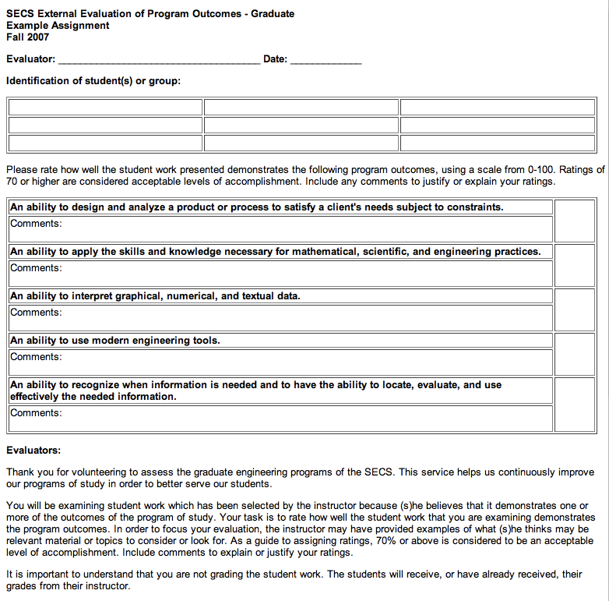
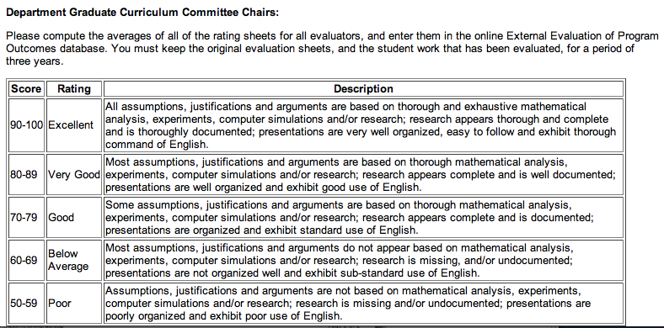
Appendix B - Example Student Evaluation Results (Indirect Measure)


ECE 550 Fall 2007
Instructor: DANIEL ALOI
Faculty Rank: Assistant Professor
Below are the Course Objectives, Ratings: (E=EXCELLENT; G=GOOD; A=AVERAGE; P=POOR; U=UNSATISFACTORY; NA=DOES NOT APPLY), Total Ratings, the Average Grade, and the Total Average Grade for course objectives. The numbers below each rating are the total number of students who gave that rating for the course objective.
Top of Form

Course Objectives | E | G | A | P | U | NA | Total Ratings | Median | Standard Deviation | Avg Grade
1. System-level understanding of GPS
2. Understanding of the GPS signal structure and characteristics
3. Understanding of the satellite constellation and its characteristics
4. Familiarity with different modes of positioning capability with GPS (accuracy)
5. Understanding of the mathematics involved in the determination of position from the range measurements
6. Impact of range error and dilution of precision on position error.
7. Familiarity of coordinate systems and timing standards
8. Understanding of GPS range error sources and mitigation techniques
Total Average Grade for Course Objectives =
Below are the Section Objectives, Ratings: (E=EXCELLENT; G=GOOD; A=AVERAGE; P=POOR; U=UNSATISFACTORY; NA=DOES NOT APPLY), Total Ratings, the Average Grade, and the total grade for the section objectives. The numbers below each rating are the total number of students who gave that rating for the section objective.
Section Objectives | E | G | A | P | U | NA | Total Ratings | Median | Standard Deviation | Avg Grade
Below are the Evaluation Questions, Ratings: (E=EXCELLENT; G=GOOD; A=AVERAGE; P=POOR; U=UNSATISFACTORY; NA=DOES NOT APPLY), Total Ratings, the Average Grade, and the Total Average Grade for each question. The numbers below each rating are the total number of students who gave that rating for the question.
Evaluation Questions (Ratings) | E | G | A | P | U | NA | Total Ratings | Median | Standard Deviation | Avg Grade
1. Making the objectives of the course clear to me.
2. Developing and presenting the course material in a clear and organized manner.
3. Stimulating and deepening my interest in the subject.
4. Motivating me to do my best work.
5. Explaining and clarifying difficult material and problem solutions.
6. Willingness to provide individual assistance to students outside of classroom hours.
7. Ability to handle questions from the class.
8. Utilization of class time.
9. Utilization of instructional aids such as blackboard, slides or viewgraph.
10. Uniformity and impartiality in grading.
11. Promptness in returning homework, laboratory reports and examinations.
12. Overall rating as a teacher
13. Value of the textbook contribution to the course
14. Value of the recitation component of the course.
15. Value of the laboratory component of the course.
16. Adequacy of the computing and/or laboratory facilities.
17. Overall rating of this course as a learning experience.
Total Average Grade for Instructor Evaluation Questions =

Below are the Evaluation Questions and the students responses to each question.
Evaluation Question (Comments)
18. INSTRUCTOR
19. COURSE
20. GRADING AND EVALUATION
21. OTHER
Below is the Student Profile section.
Student Profile
1. Hours spent per week outside the classroom for this course. | Over 9 | 6-9 | 4-6 | 2-4 | 0-2 | Total Answer
2. Your assessment of the amount of material covered in this course. | Much Too Much | Too Much | Just Right | Too Little | Much Too Little | Total Answer
3. What grade do you expect to receive in this course? | 3.50-4.00 | 3.00-3.49 | 2.50-2.99 | 2.00-2.49 | Below 2.00 | Total Answer
4. What is your approximate cumulative grade point average? | 3.50-4.00 | 3.00-3.49 | 2.50-2.99 | 2.00-2.49 | Below 2.00 | Total Answer
Below are the final grades for this course section
Course Objective =
Section Objective =
Evaluation Questions =
Final Grade =
Bottom of Form
Top of Form

Goal Cited  in OU Mission | Relevant Goal  of Unit | Student Learning  Outcomes | Methods of Assessment | Individual(s)  Responsible for Assessment Activities | Procedures for Using Assessment  Results to  Improve Program
1) Each program provides a variety of courses and curricula experiences to ensure an enriched life along with superior career preparation or enhancement. | 1a) The program will enable students to design and analyze systems composed of diverse components that must interact in prescribed fashions to meet specified objectives.  1b) The program will enable students to apply mathematical and computer skills to engineering design and analysis. | 1a) Students will demonstrate an ability to design and analyze a product or process to satisfy a client’s needs subject to constraints.  1b) Students will demonstrate an ability to apply the skills and knowledge necessary for mathematical, scientific, and engineering practices.  1c) Students will demonstrate an ability to interpret graphical, numerical, and textual data. | External evaluation;  Student end-of-course evaluations  External evaluation;  Student end-of-course evaluations  External evaluation;  Student end-of-course evaluations | Course instructors and ECE Dept. faculty  Course instructors and ECE Dept. faculty  Course instructors and ECE Dept. faculty | The ECE Dept. faculty meet each semester to review external and end-of-course evaluations and develop plans for improvement.  The ECE Dept. faculty meet each semester to review external and end-of-course evaluations and develop plans for improvement.  The ECE Dept. faculty meet each semester to review external and end-of-course evaluations and develop plans for improvement.

Goal Cited  in OU Mission | Relevant Goal  of Unit | Student Learning  Outcomes | Methods of Assessment | Individual(s)  Responsible for Assessment Activities | Procedures for Using Assessment  Results to  Improve Program
1) Each program provides a variety of courses and curricula experiences to ensure an enriched life along with superior career preparation or enhancement.  2) The university offers master’s programs that meet demonstrable needs of Michigan residents ... | 1c) The program will enable students to adapt to new technologies and methods and use these in engineering design and analysis.  2) The program will enable students to function successfully in the automotive and other global industries. | 1d) Students will demonstrate an ability to use modern engineering tools.  2) Students will demonstrate an ability to recognize when information is needed and to have the ability to locate, evaluate, and use effectively the needed information. | External evaluation;  Student end-of-course evaluations  External evaluation;  Student end-of-course evaluations | Course instructors and ECE Dept. faculty  Course instructors and ECE Dept. faculty | The ECE Dept. faculty meet each semester to review external and end-of-course evaluations and develop plans for improvement.  The ECE Dept. faculty meet each semester to review external and end-of-course evaluations and develop plans for improvement.

