Attachment 1

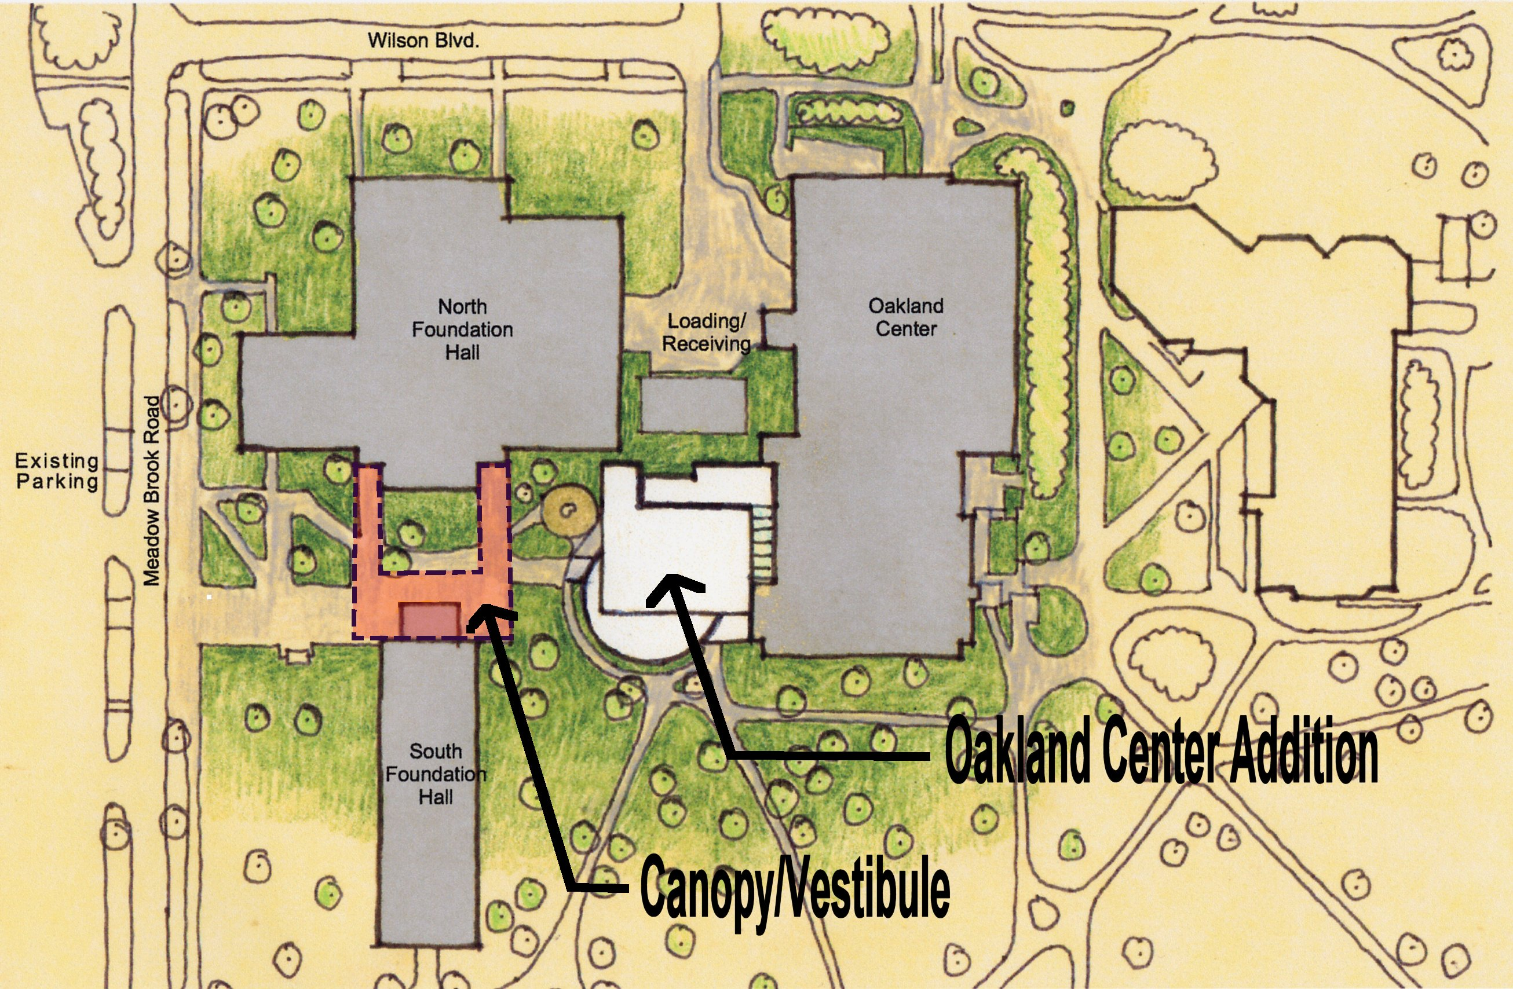

Site Plan for OC Expansion

