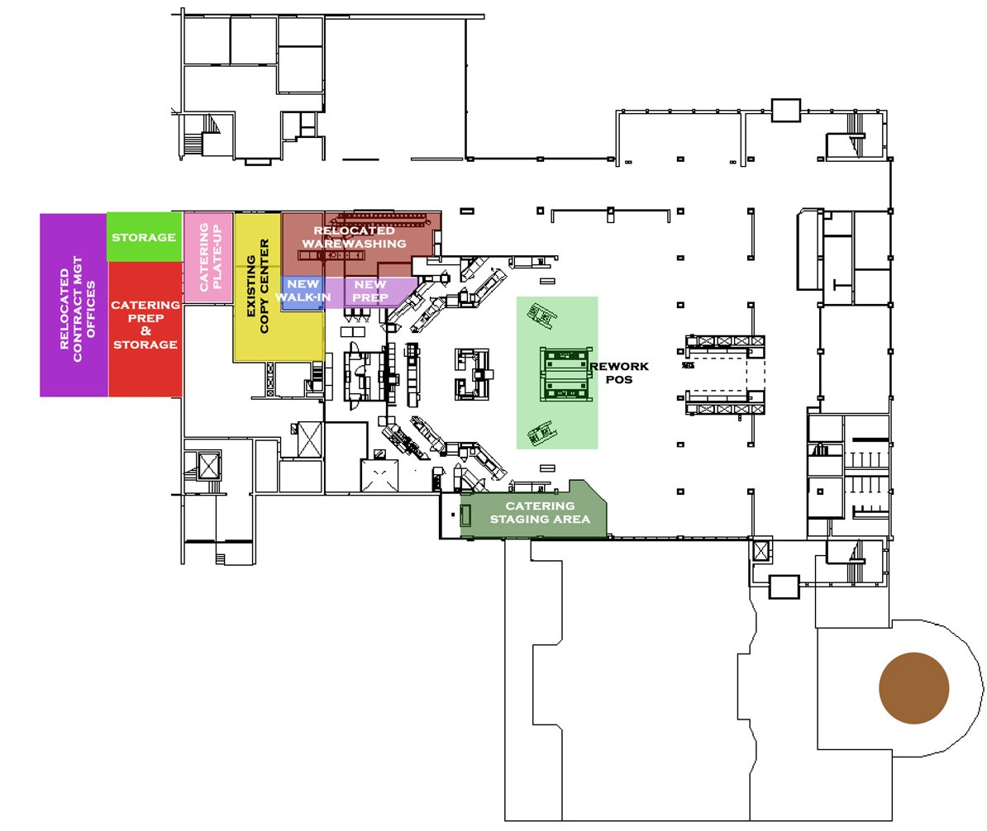

Kitchen Design: Attachment C

