Installing PulseSecure
- Go to vpn.oakland.edu
- Login with your NetID and Password

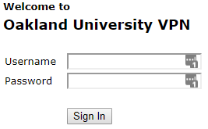

- Click the Download button

- Open the .msi file that downloaded by clicking on it at the bottom of Chrome or at the top right download arrow of Firefox, in Firefox you will have to click the save file button first.

  - Chrome:
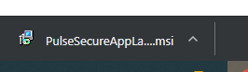

  - Firefox:

    - 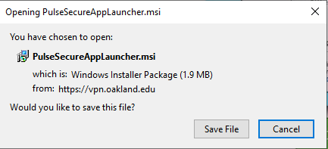

    - 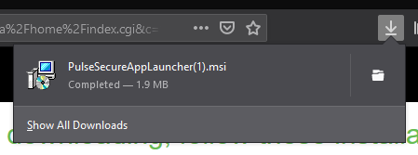

- Click OK
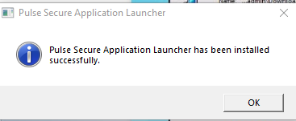

- Click on HERE
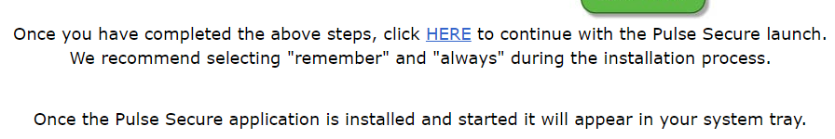
- See 7a for Chrome or 7b for Firefox
  - Click on Open Pulse Secure Ap…ation Launcher at the top of Chrome
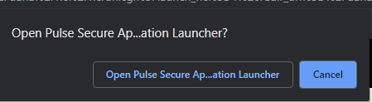
  - Click Open Link on the popup from Firefox
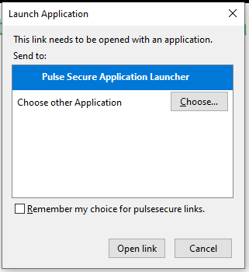

- Check Save settings and Click Yes.
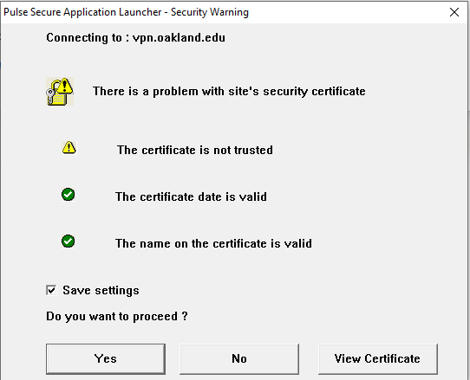

- Click Always.
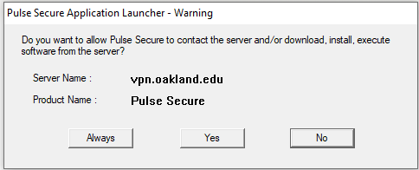

- If you get additional prompts for permission, click on allow or run.

- You should now see PulseSecure in the lower right of your Task Bar.

