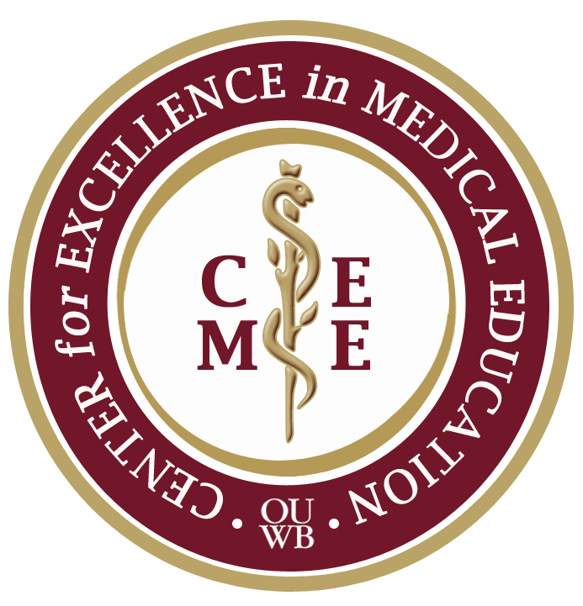

Faculty Development Sessions on Grant Writing, IRB, Research

* Information Mastery Series- *The Information Mastery Program is developed as part of the OUWB faculty development programs to assist faculty to develop high level skills in identifying, obtaining, and organizing information to achieve their goals related to medical education, clinical practice, research, judicious use of information, or life-long learning.* 
  + Copyright basics
  + Intro to Evidence Based Medicine
  + EBM Resources
  + Systematic Review
  + Searching Pub Med
  + Refworks: Introduction to Web Based Citation Management
  + Tracking your scholarly publication impact
  + Online Collaboration Tools
  + Systematic Reviews
  + Copyright and Intellectual Integrity
* Ins and Outs of Submitting an IRB to Oakland University
* Fellowship in Medical Education Series: *The fellowship program aims to introduce clinicians and scientists to the issues of thinking about and conducting research and scholarship in medical education.*
  + Medical Education Research Fundamentals
  + FME project design
* Using Research to start up a business
* Becoming a Teaching Scholar
* Writing high quality assessment items
* Dissemination of Educational Resources as Scholarship
* IRB net system and submission process
* MedEd Portal: *MedEdPORTAL Publications is a free publication service provided by the Association of American Medical Colleges in partnership with the American Dental Education Association. MedEdPORTAL Publications maintains a rigorous peer review process based on standards used in the scholarly publishing community. Each submission is scrutinized by editorial staff and independent reviewers using a standardized review instrument grounded in the tenets of scholarship. Published authors receive a formal citation for their accepted publication*
  + Preparing Materials for Submission
  + Advancing Learning Through Educational Scholarship
  + Submitting Educational Resources to MedEd Portal
  + Publishing in Med Ed Portal
* CETL: *The Center for Excellence in Teaching and Learning (CETL) supports faculty efforts to improve teaching by creating learning promote a culture* *throughout the* *university which values and rewards effective teaching, and respects and supports individual differences among learners.*
  + Writing Initiatives in Teaching Grant
  + Instructional Fair
  + Constructive Alignment
* Med Ed Week
  + MedEd Portal/DREAM
  + Podium, Poster and FME presentations
  + Outcome measurement
* MERCshop: *The Medical Education Research Certificate (MERC) program is intended to provide the knowledge necessary to understand the purposes and processes of medical education research, to become informed consumers of the medical education research literature, and to be effective collaborators in medical education research. Alone, MERC is not intended to produce independent medical education researchers.*
  + Scholarly Writing
  + Qualitative Analysis in Medical Education
  + Measuring Educational Outcomes with Reliability and Validity
  + Formulating Research Questions and Designing Studies
* Beaumont Research Institute
  + Research Retreats
    - Review recommendations of Stanford Research Institute
  + Educational Modules Through BRI
  + Research Forums
  + Research and Grant Development Series
    - Basics of Budget Development
    - Facilitating Team Science: The basics of Project Management
    - Research Project Development
    - Introduction to Grant Development
    - Grantsmanship
    - Human Investigation Committee, Brown Bag Series
  + Research Roundtables
* Capstone Training, CITI training
* OU Research, Alex Delevan, Fall Fest, October 2014
* MERCshops coming soon:
  + Formulating Research Questions and Designing Studies (9/19)
  + Searching and Evaluating the Medical Education Literature (10/17)
  + Data Management and Preparing for Statistical Consultation (11/21)
  + Measuring Educational Outcomes with Reliability & Validity (12/12)
  + Program Evaluation and Evaluation Research (1/23)
  + Qualitative Analysis Methods in Medical Education (2/27)
  + Questionnaire Design and Survey Research (3/27)
  + Introduction to Qualitative Data Collection Methods (4/24)

Updated 8/21/14