Assessment Plan

M.S. in Industrial and Systems Engineering Program
Industrial and Systems Engineering Department
School of Engineering and Computer Science
Oakland University

Approved by the ISE Dept. faculty: November 29, 2007
Overview of ISE Dept. Assessment Process.

The ISE Dept. faculty are committed to continuously improve the quality of both the undergraduate and graduate educational programs. The faculty has developed and implemented a formal plan to measure, assess, evaluate and improve the ISE programs in a systematic way. The development of this plan began with identifying the constituent groups the ISE Dept. serves, that is, students, employers and faculty; setting outcomes for each educational program that describe the skills necessary for successful modern engineering practice; and identifying outcomes for each educational program that insure the skills necessary to achieve the program learning outcomes.
The program assessment/improvement process involves both indirect and direct measures of the success of each course within each program as well as overall measures of the educational programs and of the assessment process itself. The overall success of a program is measured by whether the students of that program can demonstrate achievement of all outcomes as they graduate.

The ISE Dept. faculty have chosen an embedded approach to program assessment. Key courses have been identified in the ISE M.S. program where students have the opportunity to demonstrate the achievement of the program outcomes; the set of key courses is chosen to insure that all of the program outcomes are demonstrated. Student materials are collected from the key courses that provide evidence that the outcomes have been achieved. External evaluators, including faculty not directly involved with the course and departmental advisory board members, review these materials to establish whether the students in that class have achieved some or all of the program outcomes. Every semester, the ISE Dept. faculty review the results of these external evaluations and generate appropriate plans to improve the achievement of the program outcomes.

Each ISE course has a set of course outcomes, developed by the instructing faculty and ISE Graduate Committee, which insure the logical sequence of topics necessary to the eventual achievement of the program outcomes. At the end of each semester, the students and faculty in each course rate how well that particular course section achieved its objectives. The faculty identify the specific program outcome(s) achieved in the course and provide evidence in support of their contention. In addition, students and faculty are encouraged to comment on how well the course fits into the overall scheme of the program and to suggest improvements to the course, the course outcomes and the overall program of study. The ISE Dept. holds a faculty meeting at the beginning of each semester to review all external evaluations and end-of-course evaluations from the prior semester and develop any needed plan for improvement.

The ISE M.S. program’s assessment process is outlined as follows.

Key ISE M.S. Courses
All ISE M.S. Courses
ISE Graduate Comm.
&
ISE Dept. Faculty
External Evaluation of Program Outcomes

Program Outcomes
&
Course Outcomes
Student End-of-Course Evaluations
&
Faculty End-of-Course Evaluations

Oakland University’s Role and Mission Statement.

The following sections from Oakland University’s Role, Mission Statement and goals have relevance for the M.S. in Industrial and Systems Engineering (ISE) program:

1) “Each program provides a variety of courses and curricula experiences to ensure an enriched life along with superior career preparation or enhancement.”

2) “The university offers master’s programs that meet demonstrable needs of Michigan residents ...”

ISE M.S. Program Goals.

The ISE M.S. program goals listed below flow from the goals identified by Oakland University. In order to facilitate the understanding of linkages, the numerical references that identify the linkages are consistent throughout this plan. For example, any ISE program goal labeled “1” below flows from the O.U. goal labeled “1” above.

1a) The program will enable students to design and analyze systems composed of diverse components that must interact in prescribed fashions to meet specified objectives.

1b) The program will enable students to apply mathematical and computer skills to engineering design and analysis.

1c) The program will enable students to adapt to new technologies and methods and use these in engineering design and analysis.

2) The program will enable students to function successfully in the automotive and other global industries.

Student Learning Outcomes.

Relevant student learning outcomes were developed based on the program goals. Each of these learning outcomes are related to a program goal. The numerical references are again consistent with the programs goals as well as the university’s role and mission statement. Before graduating, students in the M.S. in ISE program will demonstrate their skills in the following areas.

1a) Students will demonstrate an ability to design and analyze a product or process to satisfy a client’s needs subject to constraints.

1b) Students will demonstrate an ability to apply the skills and knowledge necessary for mathematical, scientific, and engineering practices.

1b) Students will demonstrate an ability to interpret graphical, numerical, and textual data.

1c) Students will demonstrate an ability to use modern engineering tools.

2) Students will demonstrate an ability to recognize when information is needed and to have the ability to locate, evaluate, and use effectively the needed information.

Measures.

The overall success of the M.S. in ISE program is measured by whether the students can demonstrate achievement of all learning outcomes as they graduate. In order to assess the students’ achievement, the ISE Dept. faculty have selected one direct measure and one indirect measure.

Direct Measure. A key courses are identified in the ISE M.S. program where students have the opportunity to demonstrate the achievement of the program learning outcomes. Note that any engineering M.S. program basically consists of fifth-year elective courses. Every engineering major contains of several areas (e.g., in ISE: quality control, production systems, etc). On the undergraduate level, the program requirements are general in nature requiring the students to take courses in all areas. On the graduate level, students have freedom to select from elective-type courses with a concentration in a few areas or spread out over several areas. Thus, no single course is required for all students enrolled in the ISE M.S. program.

The ISE M.S. key courses are chosen to insure that all of the learning outcomes are demonstrated. The current key courses are ISE 583 Production Systems and Workflow Analysis, ISE 585 Statistical Quality Analysis, ISE 587 Foundations of Systems Engineering and ISE 684 Computer-Integrated Manufacturing Systems. Currently, all ISE M.S. students are required to take at least three of these four courses. Each year, two of these key courses are selected for external review (ISE 583 and ISE 587 on even years and the others on odd years).

When a key course is under review, student materials are collected that provide evidence that the outcomes have been achieved, such as homework assignments, laboratory assignments, project assignment and exams. External evaluators (faculty not directly involved with the course, engineers from industry and ISE Dept. Advisory Board members) review these materials to establish whether the students in that class have achieved some or all of the program outcomes.

The rubric used by the external evaluators is presented in Appendix A. Note that every assignment is not expected to demonstrated competency in all four learning outcomes. Hence, a customized rubric containing only the appropriate learning outcomes is generated for each assignment. The rubrics are generated by any ISE Dept. faculty member from the SECS assessment website. The ISE Dept. faculty meet to review the results of these external evaluations and generate appropriate plans to improve the achievement of the program outcomes.

Indirect Measure. Each ISE M.S. course has a set of course outcomes, developed by the instructing faculty and the ISE Dept. Graduate Committee, which insure the logical sequence of topics necessary to the eventual achievement of the program outcomes. At the end of each semester, the students in each course rate how well that particular course section achieved its outcomes (Appendix B contains an example rubric for ISE 581 Lean Principles and Application). The ISE faculty review all of these course evaluations each semester at a department faculty meeting and generate appropriate plans to improve the achievement of the program outcomes.

Documentation of Assessment Process.

All actions taken at each step of the assessment process are documented in an online assessment database. The ISE Dept. Chair, ISE Dept. Graduate Committee Chair and ISE Dept. Assessment Coordinator update this database every time action is taken in the assessment process (see example in Appendix C), and are solicited for improvements to the assessment process (see example in Appendix D). In this way, a written record is kept of both the assessment activities and of the process itself. This record is used by the ISE faculty to evaluate and improve the assessment process.

ISE Dept. Faculty Involved in the Assessment Process.

All ISE Dept. faculty members are involved in the assessment process.
Appendix A - Example External Evaluation Rubric (Direct Measure)

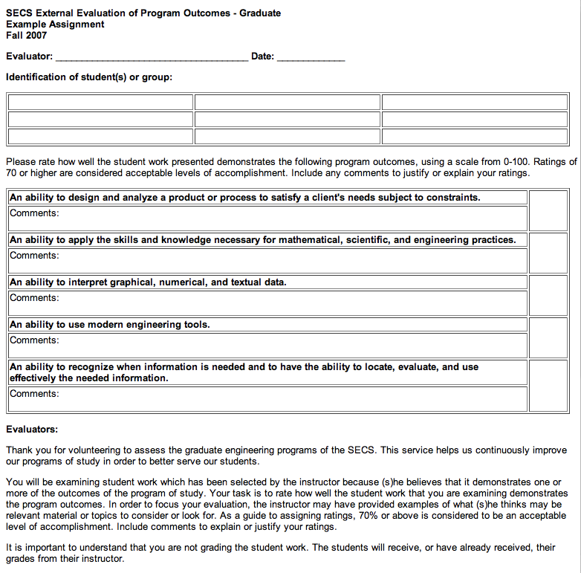
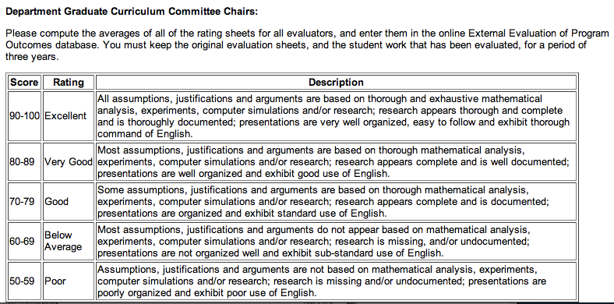
Appendix B - Example Student Evaluation Rubric (Indirect Measure)

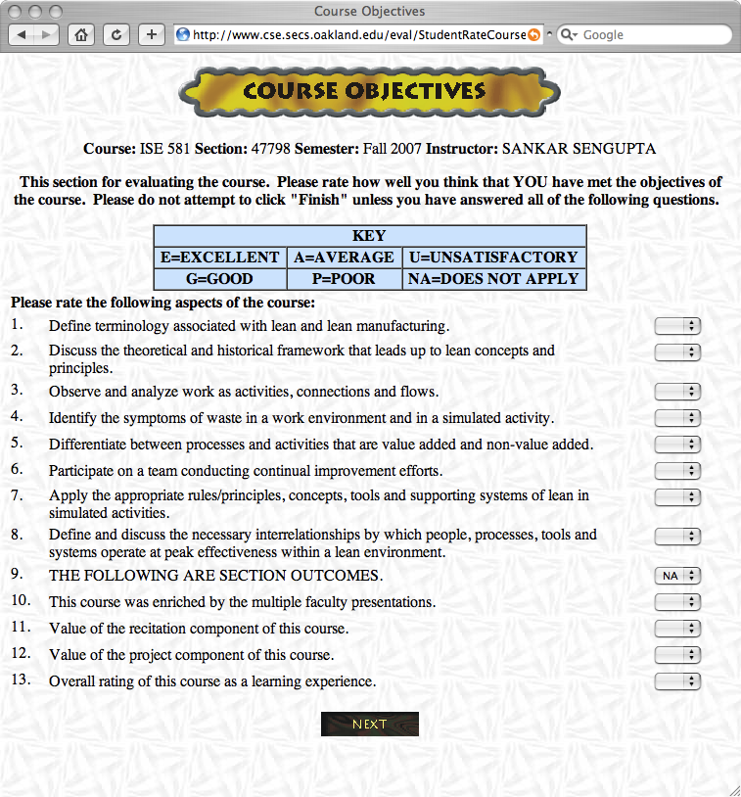

Appendix B - Example Student Evaluation Rubric (Indirect Measure)



Appendix B - Example Student Evaluation Rubric (Indirect Measure)

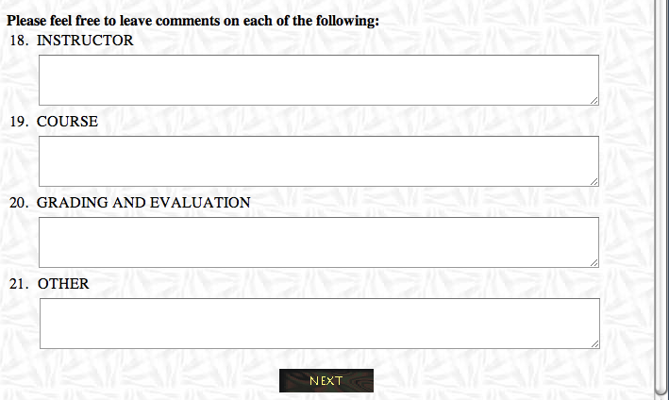

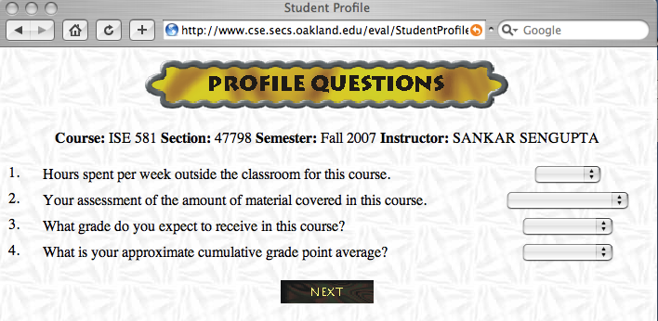

Appendix B - Example Student Evaluation Rubric (Indirect Measure)

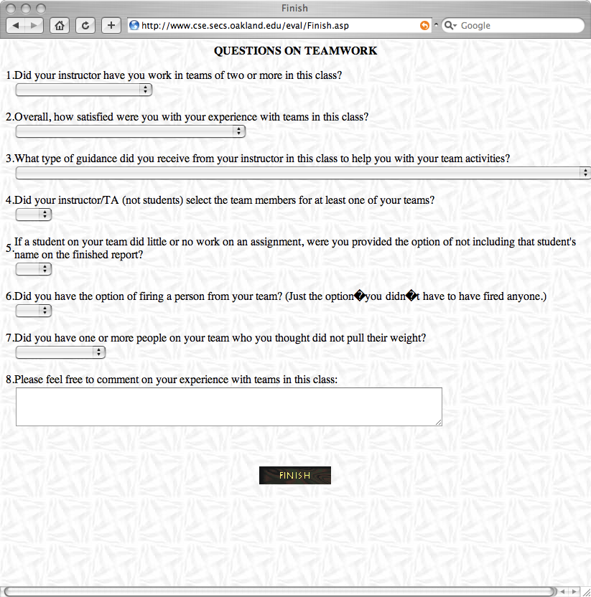
Appendix C - Assessment Documentation Online Form

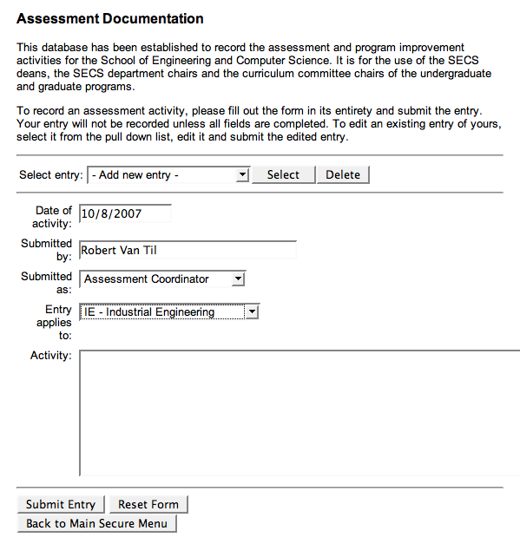
Appendix D - Program and Course Improvements Online Form

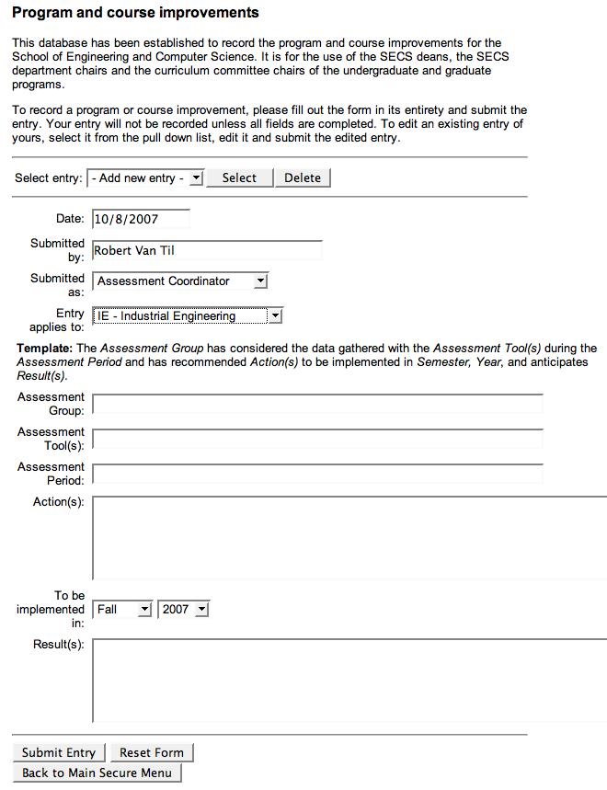

Goal Cited  in OU Mission | Relevant Goal  of Unit | Student Learning  Outcomes | Methods of Assessment | Individual(s)  Responsible for Assessment Activities | Procedures for Using Assessment  Results to  Improve Program
1) Each program provides a variety of courses and curricula experiences to ensure an enriched life along with superior career preparation or enhancement. | 1a) The program will enable students to design and analyze systems composed of diverse components that must interact in prescribed fashions to meet specified objectives.  1b) The program will enable students to apply mathematical and computer skills to engineering design and analysis. | 1a) Students will demonstrate an ability to design and analyze a product or process to satisfy a client’s needs subject to constraints.  1b) Students will demonstrate an ability to apply the skills and knowledge necessary for mathematical, scientific, and engineering practices.  1b) Students will demonstrate an ability to interpret graphical, numerical, and textual data. | External evaluation;  Student end-of-course evaluations  External evaluation;  Student end-of-course evaluations  External evaluation;  Student end-of-course evaluations | Course instructors and ISE Dept. faculty  Course instructors and ISE Dept. faculty  Course instructors and ISE Dept. faculty | The ISE Dept. faculty meet each semester to review external and end-of-course evaluations and develop plans for improvement.  The ISE Dept. faculty meet each semester to review external and end-of-course evaluations and develop plans for improvement.  The ISE Dept. faculty meet each semester to review external and end-of-course evaluations and develop plans for improvement.

Goal Cited  in OU Mission | Relevant Goal  of Unit | Student Learning  Outcomes | Methods of Assessment | Individual(s)  Responsible for Assessment Activities | Procedures for Using Assessment  Results to  Improve Program
1) Each program provides a variety of courses and curricula experiences to ensure an enriched life along with superior career preparation or enhancement.  2) The university offers master’s programs that meet demonstrable needs of Michigan residents ... | 1c) The program will enable students to adapt to new technologies and methods and use these in engineering design and analysis.  2) The program will enable students to function successfully in the automotive and other global industries. | 1c) Students will demonstrate an ability to use modern engineering tools.  2) Students will demonstrate an ability to recognize when information is needed and to have the ability to locate, evaluate, and use effectively the needed information. | External evaluation;  Student end-of-course evaluations  External evaluation;  Student end-of-course evaluations | Course instructors and ISE Dept. faculty  Course instructors and ISE Dept. faculty | The ISE Dept. faculty meet each semester to review external and end-of-course evaluations and develop plans for improvement.  The ISE Dept. faculty meet each semester to review external and end-of-course evaluations and develop plans for improvement.

