ATTACHMENT A

OAKLAND UNIVERSITY

Fiscal Year 2007

5-Year Capital Outlay Plan

I. Mission Statement

The role and mission statement for the University was adopted by the Oakland University Board of Trustees on July 21, 1982:

“As a state-supported institution of higher education, Oakland University has a three-fold mission. It offers instructional programs of high quality that lead to degrees at the baccalaureate, masters and doctoral levels as well as programs in continuing education; it advances knowledge and promotes the arts through research, scholarship, and creative activity; and it renders significant public service. In all its activities, the University strives to exemplify educational leadership.”

II. Instructional Programming
Oakland University (OU) is a doctoral research intensive university located north of Detroit in Rochester, suburban Oakland County. Through unique and distinctive academic experiences, Oakland is preparing students to make meaningful and substantial contributions to academia, the community and the workplace.
Located in a thriving region, Oakland continues to add market-driven academic programs geared to real-world needs. Students have many options for off-campus work experience at Fortune 500 companies in Oakland County, which often lead to full-time jobs after graduation.
Instructional Technology enhancements in the classrooms have become a standard expectation of OU faculty and students. Ninety-two Oakland University classrooms are equipped with enhanced instructional technology features at a Level II or higher configuration.
OU classrooms are categorized into five functional levels:
Level I - Basic Classrooms contain: Chalkboard and/or whiteboard, Projection screen, Overhead projector, OU network connectivity (Data/Voice/Video).

Level II - Technology Classrooms (Without Multimedia Podium) contain: Everything in Level 1 plus: VHS/DVD video player, Video/Data projector, Fixed AV equipment lock box.

Level III - Enhanced Technology Classrooms (With Multimedia Podium) contain: Everything in Level II plus: Multimedia presentation podium, personal computer, a document camera and an electronic white board. Wireless network access is being added to new addition and renovation classroom projects.

Level IV - Two-way Interactive Television or Distance Learning Classrooms (ITV or DL) contain: Everything within a Level III classroom plus: Multiple TV cameras, microphones, codec (video/audio compressor), I-mux (video call management), a user friendly computer touch-screen control system that provides the user with full access and control of all classroom presentation devices from the desktop, and a fax/copier.

Level V - Computer Classrooms: A computer classroom is a teaching environment where there is a computer workstation for each student participating in the class in addition to the instructor's control/presentation computer workstation. The instructor's control computer workstation may be connected to a data projection system. The instructor's workstation may also have special control capabilities that manage the functionality of all classroom computers and image displays. Mobile laptop carts containing approximately 30 units each are adding to the flexibility of making any classroom a potential Level V instructional space.

OU continues to offer courses via distance education. The two modes of delivery include live interactive video and asynchronous web-based learning opportunities.
The MiCTA/Sprint T1 network continues to provide the transmission vehicle for
the majority of OU's live two-way compressed video course activity. Currently, credit courses are being delivered to Macomb Community College’s University Center. Delivery sites change each semester with program needs. There are seven interactive video classrooms on OU’s campus that are available to provide this mode of instructional delivery. The improvement in video quality over the Internet is becoming a lower cost option for two-way interactive video applications.
OU also supports a web-based distance learning solution utilizing Web CT as the enterprise course development tool. Web CT can be used as a full "web based" solution where no face-to-face teaching is required or as a "web supplemented" course resource that enhances the standard face-to-face classroom contact between faculty and student.
During the Fall 2005 semester, OU is offering 38 course sections that are fully web-based and approximately 240 course sections that are providing some level of web supplemented activity.

Technological Enhancements

OU is dedicated to enhancing education through the use of contemporary and
emerging technologies. Since 1995, OU has committed a large share of its resources to technological enhancements, including:
- Implementation of a complete administrative software suite.
- On-line registration.
- Extended campus network to all classroom buildings and residence halls.
- Wireless Internet connections in residence halls, student apartments, east campus, and in some academic buildings along with the renovated Oakland Center.
- Elliott Hall of Business and Information Technology, a $17.5-million, 74,000-square foot, technology-rich facility.
- The Pawley Hall of Education & Human Services Building with 24 enhanced technology classrooms and an all digital video recording, playback and archive system in the School's Counseling Center.
- Significant interactive television and video conferencing capability to supplement instruction and administrative program activity.
- On-line web-based course offerings to OU's students utilizing WebCT.

- Major classroom renovation projects that included significant technology enhancement in older campus buildings.

A Growing University

Student enrollment projections through 2010 include the following:
- growing to 20,000 students for fall 2010
- a 10-percent increase in full-time undergraduate students
- increase FTIAC enrollment of minority students
- a significant increase in graduate students, responding to new
program development, greater outreach activities and advanced
technology-assisted education delivery

OU has continued to keep pace with growth by providing new and advanced academic, research and support facilities, such as:
- the Science and Engineering Building
- a renovated Hannah Hall for the School of Health Sciences
- the Elliott Hall of Business and Information Technology
- the Pawley Hall of Education and Human Services
- the renovation and expansion of the Oakland Center
- the renovation of O’Dowd Hall to provide additional classrooms
- the Recreation and Athletics Center
- the immediate repairs of Meadow Brook Hall
- the renovation of South Foundation Hall first floor

OU has added 29 new degree programs over the past five years to strengthen educational offerings.

A Campus Master Plan was finalized in 2001. It addresses expected growth and includes:
- recommendations for additional parking
- infrastructure improvements
- the identification of potential building sites for a performing arts facility, a research and development park, a new humanities facility,
expansion of the School of Engineering and Computer Science, possible future phases of student apartments

In Spring 2005, Oakland launched its first-ever comprehensive capital campaign seeking

$110 million raised by 2010. Funds will be used to support student scholarships, faculty

chairs and professorships, research endowments, academic programming and capital

enhancements.

A Distinctive University

By 2010, Oakland University will have celebrated its 50th anniversary as an institution of

higher education built on, and committed to, the liberal arts. Oakland prepares students

to make meaningful and substantial contributions to society and the workplace by

producing graduates who can think critically and creatively, communicate effectively,

navigate and use information technology, and interact well with others. Oakland strives

to deliver the intellectual capital and shape the individual character that global business,

industry and society need so badly.

In addition to equipping graduates with a broad base of knowledge and top-notch intellectual and experiential opportunities, OU is equally dedicated to the development of students in all aspects of their lives. Through a carefully thought out collection of campus life experiences, the University gives students opportunities to develop leadership, team-building, decision-making and social skills that will serve them well in their professional careers and personal lives.

Expanding Graduate Program

An Enrollment Planning Committee has projected a graduate student population
representing 20 percent of the total enrollment by 2010. Seventy-five percent of the
graduate student population will be part-time students and full-time working adults
enrolled in programs that will prepare them for leadership roles in their professions –
programs that, by 2010, will have achieved regional and national acclaim. Many of
those students will commute via the Internet.

Applied Research

OU has a number of research centers and institutes that have earned substantial
recognition. OU's Eye Research Institute and Center for Biomedical Research have
been identified as two distinctive programs that bring national recognition to OU and
serve as regional resources. OU also is fortunate to have noted researchers in the
areas of gravitational physics, electromagnetic compatibility, cardiovascular disease
and cancer, among many others. By 2010, applied research at OU will include major
contributions from a research and development park. A business incubator will link
great minds from OU and the business world to develop ideas that will affect the future
of business and Michigan's economy.

Cultural and Performing Arts

In the next decade, OU’s contribution to the arts will move beyond local boundaries to
secure a place of prominence in the region. The Department of Music, Theatre and Dance received three separate five-year accreditations for all three of its disciplines in 2002. The University is one of only a few in the country to receive all three in the same year. Historically, OU has had a strong performing arts program with record-high enrollment numbers in the last five years.

OU has earned a reputation for taking artistic risks, developing gifted artists, nurturing arts partnerships and achieving new heights of quality and professionalism.

Meadow Brook Hall, the former home of Oakland University founders Matilda and Alfred Wilson and the country’s fourth largest historic house-museum, attracts 100,000 visitors to campus each year.

Meadow Brook Art Gallery, now housed in the Department of Art and Art History,
continues to garner critical acclaim for the quality and scope of its exhibitions.

Meadow Brook Theatre, Michigan’s largest professional theatre company, has inspired
audiences and has won awards for 35 years. Both Meadow Brook Art Gallery and
Meadow Brook Theatre are invaluable resources to the community and provide a
collaboration with the academic enterprise.

Community Outreach

In 2005, the Oakland University men’s basketball team defeated Oral Roberts in the Mid-Continent Conference tournament finals to earn their first trip to the NCAA Tournament. The Grizzlies went on to defeat Alabama A&M in the opening-round game and lost in the next round to the University of North Carolina Tarheels, the eventual national champions.

For the first time in OU’s history, an OU athlete has won an Olympic gold-medal playing
with the Norwegian soccer team. Needless to say, achievements like this provide
invaluable community outreach and generate tremendous interest in OU, which will
positively impact enrollment and support.

An OU student was invited to the State of the Union Address by President Bush and participated in a panel discussion on volunteerism held the following day in recognition for his tremendous volunteer work through OU’s AmeriCorps program.

Another record-breaking crowd descended on OU’s campus for the Metro Detroit American Heart Walk. More than 25,000 participants made the October 2004 event one of the largest Heart Walks in the country.

OU’s School of Nursing recognized the outstanding Michigan nurses at the 17th annual Nightingale Awards, an event that helps raise funds for nursing scholarships.

OU and the Pontiac Oakland Symphony Orchestra joined forces to provide high-level orchestral performances to the Oakland County community.

In 2003, the University formalized a partnership with the City of Rochester to partner on a variety of reciprocal business and academic ventures. Since then, Oakland students have participated in the annual Christmas parade and other events, showcased their work in art galleries during a gallery stroll, and local merchants offer OU discounts, among other activities. The City of Rochester and OU have had a long history dating to the University’s founding in 1959. In 2005, the City of Rochester was named 39th in a list of the top 100 cities in which to live by Money Magazine and CNN Money.

Campus Setting and Services

All students should have the benefit of academic support services, especially mentoring
and small learning communities, aimed at helping them make the necessary academic
and social adjustments to achieve collegiate success.

Opening in Fall 2005 a Student Technology Center serves as a digital hub for the promotion, instruction and support of technology literacy. Through the center, professional system specialists combined with undergraduate student technology mentors will provide the training and support in one-on-one or group sessions to students that will help them become proficient in technology to help them complete

coursework in various disciplines, conduct university-related business transactions, and work-related tasks and improve personal growth skills.

In 2002, OU opened a new Student Financial Services Center in North Foundation Hall, a one-stop shop for student administrative needs. Other recent student service improvements include:

- evening tutorial services in the residence halls
- creation of a Graduate Studies and Lifelong Learning Center
- establishment of assistive technology lab for use by hearing and visually impaired students
- creation of an advising center for students who have undecided majors
- completion of 30,000 sq. ft. student center expansion
- the Trustee Academic Success Scholarship Program
- completion of parking structure
- new student apartments to bring on-campus housing capacity to
2,000, in response to the demand

 |  | OAKLAND UNIVERSITY
UNDERGRADUATE DEGREE PROGRAMS (114)
College of Arts and Sciences (83)
 | Bachelor of Arts - CASBA (52)
 | 1045 | Independent Major
 | 1055 | Art History
 | 1105 | Biology
 | 1070 | Studio Art
 | 1075 | Studio Art - Spec in Drawing
 | 1080 | Studio Art - Spec in Painting
 | 1085 | Studio Art - Spec in Photography
 | 1230 | Chemistry
 | 1405 | English
 | 1410 | English w/Concentration in Linguistics
 | 1505 | History
 | 1605 | African African-Amer Studies
 | 1610 | East Asian Studies - China
 | 1615 | East Asian Studies - Japan
 | 1620 | South Asian Studies
 | 1625 | Latin American Studies
 | 1630 | Slavic Studies
 | 1705 | Linguistics
 | 1710 | Linguistics - Modified
 | 1805 | Mathematics
 | 1980 | French Language and Literature
 | 1985 | French - Modified
 | 2011 | German Language and Literature
 | 2015 | German w/Concentration in German Studies
 | 2020 | German - Modified
 | 2060 | Latin American Lang and Civ
 | 2100 | Spanish Language and Lit
 | 2110 | Spanish - Modified
 | 2130 | Two Modern Languages
 | 2205 | Music
 | 2210 | Dance - Performing Arts
 | 2211 | Music Theatre - Performing Arts
 | 2212 | Theatre Performance - Performing Arts
 | 2214 | Theatre Production - Performing Arts
 | 2375 | Philosophy
 | 2380 | Philosophy - Modified
 | 2385 | Philosophy w/Concentration in Linguistics
 | 2405 | Physics
 | 2515 | Political Science
 | 2605 | Psychology
 | 2615 | Psychology w/Concentration in Linguistics
 | 2705 | Communication
 | 2715 | Communication w/Concentration in Linguistics
 | 2735 | Journalism
 | 2805 | Sociology/Anthropology
 | 2810 | Anthropology
 | 2815 | Anthro w/Concentration in Linguistics
 | 2820 | Sociology
 | 2825 | Soc w/Concentration in Linguistics
 | 2830 | Soc w/Spec in Criminal Justice (2 + 2)
 | 2862 | Women's Studies
 | 3700 | Economics
 | Bachelor of Music - CASBMUS (6)
 | 2240 | Music - Vocal Performance
 | 2245 | Music - Piano Performance
 | 2250 | Music - Composition
 | 2260 | Music - Organ Performance
 | 2265 | Music - Instrumental Performance
 | 2275 | Music Education K-12
 | Bachelor of Science - CASBS (16)
 | 1105 | Biology
 | 1110 | Modified Major in Biology with Concentration in Applied Statistics
 | 1125 | Biology w/Spec in Anatomy
 | 1120 | Biology w/Spec in Cell-Molecular Biology
 | 1130 | Biology w/Spec in Microbiology
 | 1225 | Biochemistry
 | 1230 | Chemistry
 | 1245 | Env Hlth Spec Public Health
 | 1250 | Env Health Spec Env/Res Mgt
 | 1255 | Env Hlth Spec Occ Hlth Safety
 | 1260 | Env Hlth Spec Toxic Subs Cntrl
 | 1805 | Mathematics
 | 1835 | Applied Statistics
 | 2405 | Physics
 | 2420 | Medical Physics
 | 2530 | Public Admin and Public Policy
 | Secondary Education Programs (9)
 | 1140 | Biology w/Secondary Cert
 | 1240 | Chemistry w/Secondary Cert
 | 1430 | English w/Secondary Cert
 | 1515 | History w/Secondary Cert
 | 1825 | Mathematics w/Secondary Cert
 | 1990 | French w/Secondary Cert
 | 2025 | German w/Secondary Cert
 | 2120 | Spanish w/Secondary Cert
 | 2430 | Physics w/Secondary Cert
School of Business Administration (8)
 | Bachelor of Science - SBABS (8)
 | 3100 | Accounting
 | 3705 | Business Economics
 | 3200 | Finance
 | 3300 | General Management
 | 3400 | Human Resource Management
 | 3500 | Management Information Systems
 | 3600 | Marketing
 | 3700 | Economics
School of Education and Human Services (2)
 | Bachelor of Science (2)
 | 4120 | Elementary Education
 | 4320 | Human Resource Development
School of Engineering and Computer Science (8)
 | Bachelor of Science (2)
 | 5020 | Computer Science
 | 5070 | Information Technology
 | Bachelor of Science in Engineering (4)
 | 5120 | Computer Engineering
 | 5140 | Electrical Engineering
 | 5160 | Mechanical Engineering
 | 5180 | Systems Engineering
 | Bachelor of Science Offered Jointly with College of Arts & Sciences (2)
 | 5040 | Engineering Chemistry
 | 5060 | Engineering Physics
School of Health Sciences (9)
 | Bachelor of Science (9)
 | 6020 | Health Sciences
 | 6041 | Occupational Safety and Health
 | 6050 | Wellness, Health Promotion, and Injury Prevention
 | 6061 | Medical Laboratory Science
 | 6062 | MLS: Cytotechnology
 | 6063 | MLS: Histotechnology
 | 6064 | MLS: Medical Technology
 | 6065 | MLS: Nuclear Med Tech
 | 6066 | MLS: Radiation Therapy
School of Nursing (3)
 | Bachelor of Science in Nursing (3)
 | 7020 | Nursing
 | 7040 | Nursing (Completion Sequence)
 | 7050 | Nursing Second BSN
University Programs (1)
 | Bachelor of General Studies (1)
 | 7510 | General Studies

UNDERGRADUATE CONCENTRATIONS AND MINORS
Undergraduate Concentrations (12)
1435 | American Studies
1835 | Applied Statistics
2850 | Archeology
2858 | Criminal Justice
1270 | Environmental Studies
1437 | Film Aesthetics and History
1995 | French Studies
6030 | Health Behavioral Sciences
1150 | Pre-Prof Studies Med/Dent/Opt
2856 | Religious Studies
2860 | Social Work
2855 | Urban Studies
Undergraduate Minors (58)
3100 | Accounting
2740 | Advertising
1605 | African African-Amer Studies
2810 | Anthropology
3810 | Applied Technology in Business
1055 | Art History
1105 | Biology
1230 | Chemistry
2705 | Communication
5020 | Computer Science
5021 | Computing
2290 | Dance
1611 | East Asian Studies
3700 | Economics
1405 | English
1265 | Environmental Health
6240 | Exercise Science
3200 | Finance
1981 | French Language
1980 | French Language and Literature
3315 | General Business
2011 | German Language
2011 | German Language and Literature
2016 | German Studies
1505 | History
4320 | Human Resource Development
3400 | Human Resource Management
3302 | International Management
5300 | International Orientation for SECS
2035 | Japanese Lang and Civ
2735 | Journalism
4350 | Labor and Employment Studies
1625 | Latin American Studies
1705 | Linguistics
3500 | Management Information Systems
3600 | Marketing
1805 | Mathematics
2205 | Music
6041 | Occupational Safety and Health
2375 | Philosophy
2405 | Physics
2515 | Political Science
3805 | Production/Operations Mgt
2605 | Psychology
2742 | Public Relations
3800 | Quantitative Methods
1630 | Slavic Studies
2820 | Sociology
1620 | South Asian Studies
2101 | Spanish Language
2100 | Spanish Language and Lit
1070 | Studio Art
2294 | Theatre
1147 | Three Science
 | Training & Development
1146 | Two Science
6050 | Wellness Health Promotion Injury Prevention
2862 | Women's Studies

OAKLAND UNIVERSITY
GRADUATE PROGRAM REPORT (86)
 | Doctor of Philosophy (9)
 | PH1900 | Applied Mathematical Sciences
 | PH1350 | Biomedical Sciences: Health and Environmental Chemistry
 | PH2490 | Biomedical Sciences: Medical Physics
 | PH4951 | Education: Educational Leadership
 | PH4950 | Education: Counseling
 | PH4952 | Education: Early Childhood Education
 | PH5160 | Mechanical Engineering
 | PH4940 | Reading Education
 | PH5180 | Systems Engineering
 | Doctor of Physical Therapy (1)
 | DP6220 | Physical Therapy
 | Doctor of Science in Physical Therapy (1)
 | DS6220 | Physical Therapy
 | Education Specialist (1)
 | ES4650 | School Administration
 | Master of Arts (6)
 | MA1105 | Biology
 | MA4400 | Counseling
 | MA1405 | English
 | MA1505 | History
 | MA1705 | Linguistics
 | MA1805 | Mathematics
 | Master of Arts in Liberal Studies (1)
 | MA1700 | Liberal Studies
 | Master of Accounting (1)
 | MA3100 | Accounting
 | Master of Arts in Teaching (3)
 | MT4120 | Elementary Education
 | MT4500 | Reading and Language Arts
 | MT4220 | Secondary Education
 | Master of Business Administration (1)
 | MB3900 | Business Administration
 | Master of Education (5)
 | ME4600 | Curriculum, Instruction and Leadership
 | ME4700 | Early Childhood Education
 | ME4610 | Educational Leadership
 | ME4620 | Educational Studies
 | ME4800 | Special Education
 | Master of Music (1)
 | MM2205 | Music
 | MP2560 | Public Administration
 | Master of Science (16)
 | MS1835 | Applied Statistics
 | MS1105 | Biology
 | MS1230 | Chemistry
 | MS5520 | Computer Science and Engineering
 | MS5540 | Electrical and Computer Engineering
 | MS5620 | Embedded Systems
 | MS5560 | Engineering Management
 | MS6240 | Exercise Science
 | MS1860 | Industrial Applied Mathematics
 | MS5580 | Information Systems Engineering
 | MS3550 | Information Technology Management
 | MS5160 | Mechanical Engineering
 | MS6220 | Physical Therapy
 | MS2405 | Physics
 | MS5600 | Software Engineering
 | MS5180 | Systems Engineering
 | Master of Science in Nursing (6)
 | MS7270 | Adult Gerontological Nurse Practitioner
 | MS7280 | Family Nurse Practitioner
 | MS7220 | Nurse Anesthesia
 | MS7265 | Nursing Acute Care
 | MS7285 | Nursing Education
 | MS7290 | RN to MSN
 | Master of Training and Development (1)
 | MD4900 | Training and Development
 | Graduate Certificate (15)
 | GC4551 | Advanced Microcomputer Applications
 | GC6245 | Clinical Exercise Science
 | GC6248 | Complementary Medicine and Wellness
 | GC6246 | Corporate and Worksite Wellness
 | GC4750 | Early Mathematics Education
 | GC6240 | Exercise Science
 | GC4550 | Microcomputer Applications
 | GC6233 | Neurological Rehabilitation
 | GC7285 | Nursing Education
 | GC6230 | Orthopedic Manual Physical Therapy
 | GC6232 | Orthopedics
 | GC6231 | Pediatric Rehabilitation
 | GC1880 | Statistical Methods
 | GC6234 | Teaching and Learning for Rehabilitation Professionals
 | GC1720 | Teaching English as Second Language
 | Post Masters Graduate Certificate (17)
 | PM3100 | Accounting
 | PM7270 | Adult Gerontological Nurse Practitioner
 | PM4561 | Advanced Reading, Language Arts and Literature
 | PM3705 | Business Economics
 | PM4660 | Educational Administration
 | PM3850 | Entrepreneurship
 | PM7280 | Family Nurse Practitioner
 | PM3200 | Finance
 | PM3300 | General Management
 | PM4670 | Higher Education
 | PM3400 | Human Resources Management
 | PM3305 | International Business
 | PM3500 | Management Information Systems
 | PM3600 | Marketing
 | PM7220 | Nurse Anesthesia
 | PM3805 | Production/Operations Management
 | PM4560 | Reading, Language Arts and Literature

III. Staffing and Enrollment

The following tables and graphs are provided:

Figure 1 - Faculty and Staff Full Time Equivalent (FTE) by Program, FY 2003-04
This chart shows the FTE for faculty, administration and clerical/service for both instructional disciplines and non-instructional program classes.

Figure 2 - Student Credit Hours by Level and by Program, FY 2004-05
This chart shows credit hours awarded by instructional discipline.

Figure 3 - Degrees Awarded by Program, FY 2003-04
This chart shows the degrees awarded by program.

Figure 4 - Enrollment Trends from Fall 1998 to Fall 2005

This graphic shows the growth over the last six years in undergraduate and
graduate resident students and undergraduate and graduate non-resident
students. During this period OU’s enrollment increased from 14,289 to 17,339, an increase of over 18%.

Figure 5 – Enrollment Projections by School/College and Level, Fall 2005 – Fall 2010

OU continues to experience increases in enrollments.

Figure 6 - Gross Square Feet per Student in Michigan, FY 2004

This chart shows that OU is last in gross square footage per student of the 15 Michigan institutions.

Future Staffing Needs

OU currently employs over 2,800 full and part-time faculty and staff and over 4,800 student employees. In addition, there are over 100 employees of contract service providers for food service, bookstore, and some custodial services. Faculty and staff will grow with increased enrollment.

Average Class Size

Average class size for undergraduate instruction in fall 2003 was 34, up slightly from fall 2002. Graduate class size in fall 2003 was 20, up from fall 2002. It is important to the institutional character that the size of classes remains small. However, larger
classes have been a cost-effective way to absorb growth.

IV. Facility Assessment

Utilization Rates

OU has the lowest building square footage per student of any of the 15 public universities. However, a comparison of its programmatic mix with its doctoral programs and the relatively large number of engineering and science programs would lead to the conclusion that it should at least be near the overall average in total space. Program by program comparisons to national norms for disciplines indicates that all programs, even the School of Business with its new facility, fall short in space.

Classroom utilization is also very high, especially in the evenings. OU’s enrollment includes a large number of non-traditional students. Demand for evening classes far exceeds available facilities. A large number of evening classes are offered at area high schools.

Mandated Standards

Mandated standards for animal research are met through the Biomedical Research Facility, which was completed in 1999.

Functionality

The limited amount of specialized program space affects overall space functionality. This is particularly evident in the most impacted areas of Engineering and in the Performing Arts. Recent facilities additions for the sciences, business and education provide good space for programmatic needs. Most academic programs on the OU campus are offered in the following buildings:

- Dodge Hall of Engineering - Completed in 1969, houses engineering and biology laboratories, offices, and classrooms. It also provides space for the Eye Research Institute and the administrative/academic-computing center. The School of Engineering and Computer Science has a significant space deficit compared to national standards. This deficit would be significantly reduced by the construction of the proposed Engineering Center.

- Hannah Hall of Science - Completed in 1961, houses science, health science, and engineering laboratories as well as classrooms and offices. Air conditioning was added as part of a major energy project undertaken by OU several years ago. Portions of the building were renovated to accommodate health sciences as part of the State funded Science and Engineering Building.

- Kresge Library – This building was completed in 1961 with additions in 1989. This is the central library for the institution.

- North Foundation Hall – This building was completed in 1959, and is primarily an administrative services building, but also includes three classrooms. The building is receiving a general facelift and significant improvements to the air distribution system. OU has been studying options for improving student services.

- O’Dowd Hall - Completed in 1982, this building houses the School of Nursing, the Graduate Office, the Registrar, the Departments of History, Linguistics and Philosophy, Cooley Law School, and a number of general purpose classrooms. The building continues to suffer from leaks along the curtain wall that have been a problem for a number of years. The limited amount of space occupied by the School of Education and Human Services that was recently vacated, will be used to accommodate growth of other programs.

- South Foundation Hall - Completed in 1959, this building is primarily a classroom building. OU has been adding technology to the classrooms over the past several years. This building is used by nearly all academic disciplines.

- Varner Hall - Completed in 1970, houses the departments of Music, Theatre and Dance (MTD), Political Science, and Sociology/Anthropology. The facilities for MTD are inadequate to meet the needs of their growth program.

- Wilson Hall - Completed in 1967, houses the departments of Art and Art History, English, Modern Languages and Literature, and Rhetoric, Communications and Journalism. It also houses Meadow Brook Theatre and several administrative offices. The academic units in this building are cramped for space.

- Elliott Hall - Completed in 2000, houses the School of Business Administration and Information Technology.

- Pawley Hall - Completed in 2002, houses the School of Education and Human Services, as well as the Lowry Child Development Center. This state of the art facility is adequate to meet the needs of the school’s planned growth program.

Although academic programs are offered in other facilities and there are a number of other service buildings and auxiliary buildings, the above are the major academic facilities. The average age of buildings on the main campus is 30 years old. The average age for the entire campus is 47 years old. In general, buildings are in adequate condition. OU maintains a comprehensive list of deferred maintenance projects, which is updated annually.

Replacement Value of Facilities

The replacement value of OU’s nearly 3 million square feet, including Meadow Brook Hall is estimated at $644 million.

Utility Systems Condition

The utility systems in facilities (i.e., heating, ventilation, air conditioning (HVAC), water, sewage, and electrical) are in varying degrees of condition, depending on facility age. All are fully functional, with those in the 20 to 30 year age group needing upgrades to increase efficiency and effectiveness of operation.

The existing water/sewage infrastructure is adequate to serve the projected programming needs out at least 10 years, due to a recently installed additional water source. An upgrade to the electrical substation was completed, which included cabling, switchgear, and a new substation. This upgrade will meet projected electrical needs for at least the next 15 years. Additional upgrades to infrastructure throughout campus will be required as needs occur.

Facility Infrastructure Condition

The pavement/structural infrastructure is generally in good serviceable condition. Funds are allocated to pavement/sidewalk repair to restore the most deteriorated portions, but due to recent budget constraints, the allocation has been reduced.

Land

OU’s campus includes nearly 1,500 acres. The main campus is approximately 350 acres. The remaining campus includes several major developments (a faculty staff subdivision, the National Register Meadow Brook Estate, two OU-affiliated golf courses), a large amount of wetland, and significant underdeveloped acreage. The Campus Master Plan, approved by the Board of Trustees in April 2001, has identified future uses for all of the undeveloped property.

Buildings Obligated to the State Building Authority

The following buildings/portions of buildings are bonded through State bonds:
Library wings – lease expiration in 2008
Science and Engineering Building – lease expiration in 2034
Elliott Hall – lease expiration in 2040
Pawley Hall – lease expiration in 2042

The following facilities are bonded through OU/OU Foundation bonds:
Golf course - final payment in 2026
Recreation and Athletic Center - final payment in 2026
Student Apartments – final payment in 2031
Electrical Power Upgrade – final payment in 2031
Parking Structure – final payment in 2031
Oakland Center Expansion – final payment in 2031

Fall of 2004 General Purpose Classroom Utilization Report

Bldg/Room | Seat Count | % of Modules Used Per Semester  (15 modules) | % of Seats Used Per Semester
Dodge Hall (6)
200 | 108 | 73.3% | 72.8%
202 | 52 | 73.3% | 48.6%
203 | 77 | 73.3% | 51.6%
204 | 25 | 40.0% | 64.8%
236 | 25 | 73.3% | 62.0%
237 | 25 | 46.7% | 80.0%
Total/Average | 312 | 63.3% | 63.3%
Elliott Hall (9)
204 | 35 | 73.3% | 70.6%
206 | 35 | 100.0% | 62.0%
208 | 45 | 80.0% | 62.0%
210 | 45 | 80.0% | 76.5%
212 | 45 | 93.3% | 64.8%
214 | 44 | 80.0% | 66.1%
235 | 40 | 80.0% | 64.4%
237 | 40 | 86.7% | 55.0%
239 | 40 | 46.7% | 72.1%
Total/Average | 369 | 80.0% | 65.9%
Hannah Hall (5)
190 | 187 | 100.0% | 41.4%
195 | 187 | 100.0% | 44.9%
220 | 40 | 60.0% | 71.7%
225 | 30 | 73.3% | 58.0%
350 | 40 | 73.3% | 59.4%
Total/Average | 484 | 81.3% | 55.1%
North Foundation (2)
156 | 157 | 86.7% | 61.1%
159 | 90 | 73.3% | 80.4%
Total/Average | 247 | 80.0% | 70.8%
O'Dowd Hall (7)
108 | 60 | 93.3% | 84.4%
110 | 60 | 100.0% | 85.5%
202A | 85 | 66.7% | 57.8%
202B | 105 | 80.0% | 59.3%
203 | 229 | 60.0% | 46.5%
204 | 178 | 80.0% | 37.0%
212 | 60 | 86.7% | 66.4%
Total/Average | 777 | 81.0% | 62.4%
Pawley Hall (11)
302 | 72 | 93.3% | 70.1%
306 | 48 | 80.0% | 63.4%
307 | 48 | 86.7% | 61.7%
308 | 48 | 80.0% | 50.0%
309 | 48 | 73.3% | 55.2%
310 | 36 | 80.0% | 54.6%
312 | 36 | 66.7% | 59.0%
314 | 48 | 86.7% | 62.2%
316 | 48 | 60.0% | 77.8%
318 | 48 | 66.7% | 71.1%
320 | 36 | 53.3% | 64.2%
Total/Average | 516 | 75.2% | 62.7%
Sci & Eng Bldg (13)
93 | 38 | 40.0% | 62.5%
130 | 42 | 66.7% | 60.3%
164 | 64 | 100.0% | 58.4%
168 | 64 | 66.7% | 64.2%
172 | 64 | 93.3% | 58.9%
185 | 50 | 73.3% | 54.0%
187 | 36 | 53.3% | 53.7%
364 | 30 | 26.7% | 90.0%
376 | 30 | 53.3% | 49.5%
378 | 30 | 60.0% | 44.4%
384 | 44 | 73.3% | 63.4%
386 | 40 | 86.7% | 60.0%
388 | 30 | 40.0% | 90.7%
Total/Average | 562 | 59.5% | 62.3%
South Foundation (37)
163 | 70 | 86.7% | 85.2%
164 | 48 | 100.0% | 47.9%
165 | 75 | 80.0% | 56.6%
166 | 48 | 86.7% | 53.8%
167 | 30 | 66.7% | 62.0%
168 | 48 | 86.7% | 59.2%
169 | 40 | 33.3% | 68.8%
170 | 48 | 100.0% | 51.7%
171 | 40 | 60.0% | 75.0%
172 | 48 | 93.3% | 57.9%
173 | 48 | 66.7% | 53.6%
174 | 48 | 86.7% | 45.7%
176 | 48 | 60.0% | 44.3%
263 | 75 | 86.7% | 75.1%
265 | 25 | 73.3% | 71.5%
266 | 48 | 73.3% | 53.5%
268 | 48 | 60.0% | 47.7%
269 | 48 | 80.0% | 56.3%
270 | 48 | 66.7% | 58.3%
271 | 48 | 86.7% | 54.2%
272 | 48 | 40.0% | 62.8%
273 | 48 | 80.0% | 47.0%
274 | 48 | 86.7% | 46.5%
276 | 48 | 53.3% | 46.6%
363 | 70 | 80.0% | 62.7%
364 | 48 | 66.7% | 52.3%
365 | 75 | 53.3% | 72.0%
366 | 48 | 73.3% | 49.1%
367 | 48 | 80.0% | 47.0%
368 | 48 | 53.3% | 44.3%
369 | 48 | 80.0% | 47.7%
370 | 48 | 60.0% | 43.1%
371 | 48 | 86.7% | 52.8%
372 | 48 | 53.3% | 44.0%
373 | 48 | 86.7% | 46.8%
374 | 48 | 86.7% | 46.6%
376 | 48 | 60.0% | 57.4%
Total/Average | 1844 | 73.3% | 55.3%
Varner Hall (4)
205 | 90 | 93.3% | 72.8%
206 | 90 | 80.0% | 80.7%
229 | 25 | 20.0% | 88.0%
479 | 60 | 60.0% | 47.5%
Total/Average | 265 | 63.3% | 72.3%
Wilson Hall (6)
102 | 60 | 73.3% | 68.2%
105 | 60 | 73.3% | 66.2%
124 | 90 | 80.0% | 73.8%
301 | 20 | 33.3% | 80.0%
313 | 25 | 60.0% | 80.4%
416 | 15 | 26.7% | 68.3%
Total/Average | 270 | 57.8% | 72.8%
UNIVERSITY (100) | 5646 | 72.1% | 61.0%

Utilization Report Summary

For the Fall 2004 semester, general purpose classrooms are being used 72.1% of the time. On the average, 61.0% of the seats in these classrooms are filled. Evening classrooms utilization is at nearly 100%. 133 classes (59 day and 74 evening) were held in non-general purpose classrooms (conference rooms, meeting rooms, and laboratories) due to the unavailability of general purpose classrooms.

OAKLAND UNIVERSITY

FACILITY CONDITION ASSESSMENT

DEFERRED MAINTENANCE - CAPITAL RENEWAL - PLANT ADAPTATION

BACKLOG

January 2005

The Facilities Management computerized Deferred Maintenance – Capital Renewal – Plant Adaptation Backlog, is a relational database management system, containing 840 line items - totaling over $118 million. The present list has been developed with Oakland University staff, as time permits, surveying all campus buildings. In addition to this summary report, the database is capable of producing ad-hoc reports by priority ranking, building system, and backlog category.

The objective with this document, in addition to identifying our needs, is to raise awareness of the deferred maintenance liability, and to serve as a point of departure for broader facilities planning.

We are planning a Request for Proposal from an outside firm to do a complete Physical Facilities Assessment in 2006. This assessment is critical to identify needs, establish scope, determine costs and prioritize facility projects for the University. This will assure we have a thorough and accurate plan for years to come.

MAJOR CHANGES FROM LAST YEAR’S REPORT INCLUDE:

- $13,000,000 net added items for Housing and Facility Condition Assessments
- $ 5,000,000 net added for storm water management on the golf course
- $ 5,000,000 net added to address storm water issues on the main
- $ 2,000,000 net added to address traffic issues
$25,000,000 TOTAL

DEFINITIONS

 DEFERRED MAINTENANCE and REPAIR are those actual work tasks/projects, from the current and prior years, that were not included in the regular maintenance process because they could not be funded within available operating budget dollars. It includes postponed repairs, as well as unscheduled corrective and preventive maintenance of buildings and grounds systems. Deferred maintenance consists of unfunded maintenance; the lack of which results either in a progressive deterioration of the facility, or an adverse impact on the functionality of the building/grounds system.

 CAPITAL RENEWAL and REPLACEMENT is the systematic management process to identify, plan and budget for known future cyclical renewal and replacement requirements; which extend the useful service life, and retain the functional condition of campus facilities and building systems, that are not normally contained in the annual operating budget. This includes major systems that have a maintenance cycle typically in excess of five years (e.g., roof replacement, resurfacing of roads, HVAC System replacement, etc.). These expenditures keep the physical plant in reliable operating condition for its present use.

 PLANT ADAPTATION is the programmatic process to plan and fund for either (1) the evolving use of the institution (remodeling, alterations, renovations, etc.), or (2) changing standards (campus master plans, architectural standards, regulatory compliance, etc.). These expenditures are over and above normal maintenance, and are not typically contained in the annual operating budget.

 FACILITIES CONDITION NEEDS INDEX (FCNI) Facility Condition Needs Index provides a relative measure for comparing one building (or group of buildings) to another. The index is a simple calculation, derived by dividing total project costs (for the ten-year window) by total facility replacement cost (FRC). When applying the index as an evaluation tool, the lower the number, the better the facility condition. It should also be noted that this is an index, not a percentage. It can (and often does in the case of historic facilities) exceed 1.00. (This index will always be higher than a related facility condition index (FCI) which only recognizes deferred maintenance needs, rather then the total needs to meet current standards)

Facility Condition Needs Index (FCNI)
 | Individual Building
 | FCNI Range |  | Condition Description
 | 0.01 - 0.05 |  | Excellent condition, typically new construction
 | 0.06 - 0.15 |  | Good condition, renovations occur on schedule
 | 0.16 - 0.30 |  | Fair condition, in need of normal renovation
 | 0.31 - 0.40 |  | Below average condition, major renovation required
 | 0.41 - 0.59 |  | Poor condition, gut / renovation indicated
 | 0.60 and above |  | Complete facility replacement indicated

FACILITY CONDITION ASSESSMENT RANKING

PRIORITY 1 Current Critical (Immediate)
Projects in this category require immediate action to:
- return a facility to normal operation
- stop accelerated deterioration
- correct a cited safety hazard

PRIORITY 2 Potentially Critical (Within Year One)
Projects in this category, if not corrected expeditiously, will become critical within a year. Situations in this category include:
- intermittent interruptions
- rapid deterioration
- potential safety hazards

PRIORITY 3 Necessary – Not yet Critical (Within Year Two-Five)
Projects in this category include conditions requiring prompt attention to preclude predictable deterioration or potential down time and the associated damage or higher costs if deferred further.

PRIORITY 4 Recommended (Within Year Six-Ten)
Projects in this category include items that represent a sensible improvement to existing conditions. These are not required for the most basic function of a facility; however, Priority 4 projects will either improve overall usability and/or reduce long-term maintenance.

SOURCE: Association of Higher Education Facilities Officers (APPA)

ABBREVIATIONS

ESTIMATED COST - Order of Magnitude - Estimate to nearest hundred dollars.
Backlog contains those line items over $1,000 expressed in
year 2005 dollars.

CAMPUS SYSTEM - Accessibility (AC)
Electrical (EL)
Energy Management (EN)
Exterior Structure (ES)
Fire/Life Safety (FS)
Health (HE)
High Temperature/Hot Water (HT)
HVAC (HV)
Interior/Finish Systems (IS)
Plumbing (PL)
Roads, Walks, Parking Lots (RW)
Site (SI)
Vertical Transportation (VT)

CATEGORY - Refer to Category Definitions.
Deferred Maintenance and Repair (DM)
Capital Renewal and Replacement (CR)
Plant Adaptation (PA)

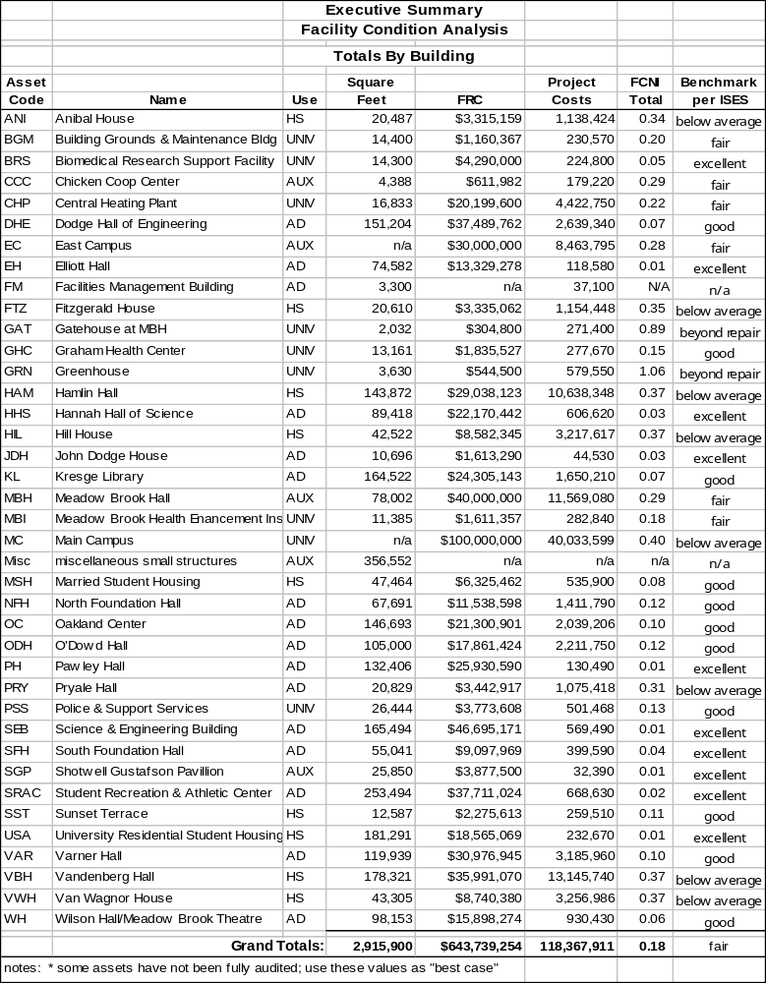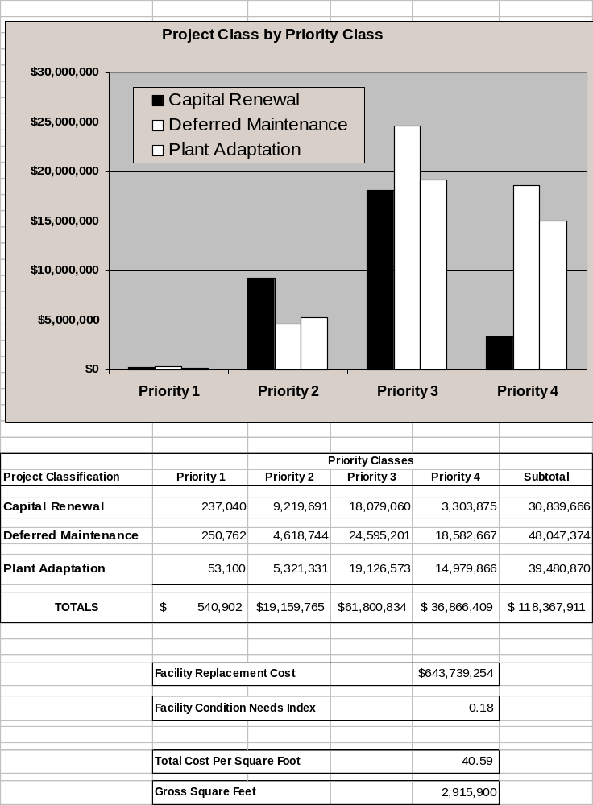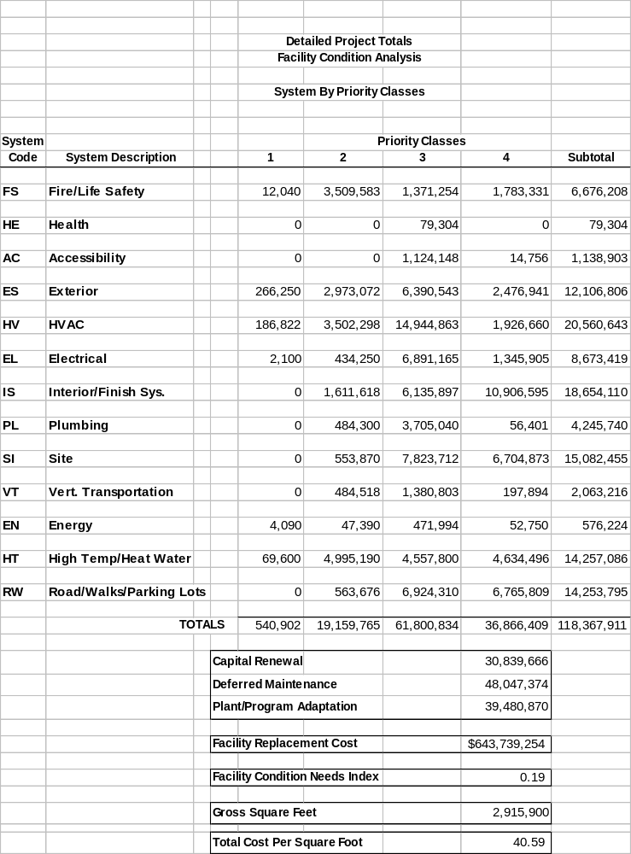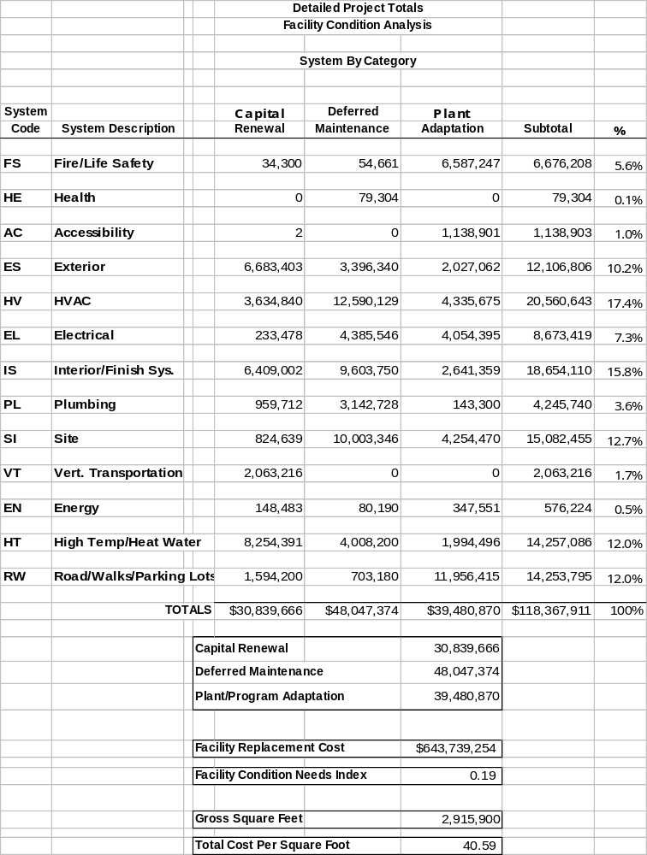

V. Implementation Plan

OU has prioritized its capital program to address the most pressing space deficits and to be responsive to programmatic and technology changes.

State Funding Request

Per the guidance in State Budget Office letter of September 8, 2005, Subject: Fiscal Year 2007 Capital Outlay Budget Information, only Oakland University's top priority capital outlay request is to be submitted. In accordance with that guidance, OU provides the following as the top priority:

Oakland University Engineering Center ($64.4 million)
The proposed Oakland University Engineering Center (OUEC) is designed to provide appropriate instructional and research facilities for programs that support automotive, defense and other industries critical to the economy of southeastern Michigan and the State of Michigan as a whole. The OUEC will add approximately 42,225 square feet of assignable space to the School of Engineering and Computer Science (SECS), sufficient to house approximately one-third of the School, as well as 39,214 square feet of assignable general purpose classroom space to support the growth of the overall student population. The repair/renovation of 5,000 square feet of space (being vacated by functions moving into the new OUEC) for the School of Health Services, will support the Wellness, Health Promotion, and Injury Prevention Program and the Exercise Science Program.

Supplemental State Funding Requests

In the future, as additional state projects are considered, OU has need for the following based on program growth and opportunity:

NFH Student Services Addition
The proposed 19,400 square foot addition will enable advising services in one location and allow for a major upgrade of two heavily used classrooms, bathrooms and the conversion of existing office space adjacent to these services into classrooms.

Varner Hall Addition and Renovation
The proposed addition would house the Music, Theatre and Dance Department with the space vacated in Varner renovated into general purpose classrooms.

Human Health Building
The proposed building will house the School of Health Sciences and the School of Nursing, and the Academic Excellence Center.

University Funded Priorities

Energy Project
This project would fund the energy and deferred maintenance backlog projects identified in a campus wide energy audit conducted by Chevron Energy Services.

Parking Garage
The proposed parking deck would provide 637 parking spaces to accommodate the increased demand as OU grows, and the plan is to house the Police Department in the parking deck.

Deferred Maintenance

Priorities for maintenance funding are based on an inventory of the deferred maintenance needs for the entire campus. This inventory is organized into three levels of priority. Generally, projects in priority one are funded ahead of projects in the other two categories. However, sometimes programmatic needs impact funding. The list is reviewed annually for priority adjustments. Over the past several years, OU has invested an average of nearly $1 million per year in deferred maintenance projects.

State Building Authority Projects

The $31.5 million Pawley Hall of Education and Human Services Building was recently completed. The 132,000 square foot facility is fully occupied.

Alternatives

Distance learning, as previously discussed, is a supplement to the on-site programs. It is not considered a significant alternative to face-to-face, on-site education for the student population served by OU.

Oakland University

FY 2007 CAPITAL OUTLAY PROJECT REQUEST

Engineering Center
Total Project Cost: $64,357,704
November, 2005

==========================================================================

Is The Project A Renovation or New Construction? Ren x New x
Is There a 5 Year Master Plan Available? Yes x No ___
Are Professionally Developed Program Statement and/or
Schematic Plans Available Now? Yes x No
Are Match Resources Currently Available? Yes ___ No x*
Has the University Identified Available Operating Funds? Yes x_ No _

*See Paragraph D below

A. Project Description Narrative
The proposed Oakland University Engineering Center (OUEC) is designed to provide appropriate instructional and research facilities for programs that support automotive, defense and other industries critical to the economy of southeastern Michigan and the State of Michigan as a whole. The OUEC will add approximately 42,225 square feet of assignable space to the School of Engineering and Computer Science (SECS), sufficient to house approximately one-third of the School, as well as 39,214 square feet of assignable general purpose classroom space to support the growth of the overall student population, currently 17,339. The repair/renovation of 5,000 square feet of space (being vacated by functions moving into the new OUEC) for the School of Health Services, will support the Wellness, Health Promotion, Injury Prevention Program, and the Exercise Science Program.

The new OUEC will house the following facilities:
- Integrated Design Laboratory (IDL);
- Advanced Design Laboratory (ADL);
- Engineering Student Learning Center (ESLC);
- Department of Computer Science and Engineering;
- Thirteen general purpose classrooms;
- A 300-person classroom/auditorium.
The Integrated Design Laboratory is envisioned as a grouping of laboratories containing high-visibility-freshmen and senior project design laboratories for all undergraduate programs, a number of computer facilities and all the common core course laboratories. A core arrangement such as this will re-affirm OU’s commitment to the “hands on” philosophy of the founding SECS faculty. It will integrate the learner’s design experience throughout the curriculum from freshmen through graduate level and will further enhance the unique character of the undergraduate engineering experience at OU through direct design opportunities. The OUEC will not only provide a highly visible focal point to the instructional, research and development activities of the SECS, but will also provide an opportunity to showcase our close interaction with the automotive industry and highlight our contributions to the economic development of the region.
The Advanced Design Laboratory will house several advanced research and development projects of the SECS, with particular emphasis on the already mature interaction with the automotive industry.
The Engineering Learning Center will provide for multiple functions, including advising, tutoring, intern/scholarships and a student lounge. The student lounge will be not only a quiet place to do homework between classes, but also a social gathering place for students and student organizations and, above all, a place where lower classmen can get instant structured and unstructured advice and help from senior students.
The OUEC will incorporate elements currently residing in several other facilities on campus while expanding programs necessary to maintain OU’s leadership in engineering for automotive, defense and other technical industries. Nearly two-thirds of the SECS programs will remain within the current Science and Engineering complex, and the OUEC will be located in close proximity to them within the campus environment. The previous Capital Outlay Project Request referred to this project as an Engineering Design Center with a program of 62,900 net square feet. The change in name to Oakland University Engineering Center better reflects the facility as the core of engineering education at the University. The increase in requested program amount is a result of added general purpose classrooms to provide badly needed classroom space. It is anticipated that the programming and design phase will require one year, followed by two years of construction.
- Other Alternatives Considered
The School of Engineering and Computer Science will be the primary occupant of the proposed new facility. Currently, programs are housed in the Science and Engineering complex and scattered among five buildings. Relative to national norms, the School has only about one-half of the teaching and research lab space for the types of programs being delivered. There is no other space on campus that could be cost effectively renovated to meet the needs of these programs. In general, OU has one of the lowest ratios of space to students of all the public universities in Michigan. Growth in space has not nearly kept pace with enrollment growth, particularly in the SECS.
OU has recently entered into a partnership with Macomb Community College to offer engineering degrees using a combination of facilities at Macomb and OU. This program is not a substitute for continued growth at OU. Without the proposed new facility, it will not be possible for OU to continue its dynamic growth in programs for automotive related disciplines and will not be able to help meet the demand for qualified graduates in this field that is so critical to the State’s economy.

- Programmatic Benefit to State of Taxpayers and Specific Clientele or Constituencies
The demand for qualified graduates in the areas of computing and automotive technology fields continues to exceed the number available. With its prime location adjacent to a number of auto-related and defense-related industry headquarters at the intellectual center of the global automotive industry, and its rapidly growing School of Engineering and Computer Science, OU is poised to help meet this demand. OUEC is designed to enhance use of existing facilities and provide additional facilities for instructional programs and industry-related initiatives. OU provides a number of services directly to industry, primarily in the form of research projects, tailored education initiatives, and state-supported grants.

- Funding Resource
If this project receives State funding approval, plans are in place to immediately begin soliciting private support as part of the University's comprehensive campaign.

OAKLAND UNIVERSITY |  |  |  |  |  |  |  | DATE: | November, 2005
CAPITAL OUTLAY ESTIMATE |  |  |  |  |  |  |  | FILE:
PROJECT: |  |  |  | Engineering Center
ARCH/ENG: |  |  |  | n/a
PHASE: |  |  |  | Budget
 |  |  |  | ASF | Efficiency | Gross SF |  | $/SF | Cost | Totals
1. | Building:
 | a. | Classrooms |  | 39,214 | 66% | 59,415 |  | $230 | $13,665,450
 | b. | IDL |  | 21,780 | 61% | 35,705 |  | $357 | $12,746,685
 | c. | ADL |  | 7,658 | 61% | 12,554 |  | $357 | $4,481,778
 | d. | ESLC |  | 2,860 | 61% | 4,689 |  | $153 | $717,417
 | e. | CSE Departmental Office |  | 5,117 | 61% | 8,389 |  | $153 | $1,283,517
 | f. | Gathering spaces |  | 3,450 | 61% | 5,656 |  | $191 | $1,080,296
 | g | Technical Support |  | 1,360 | 61% | 2,230 |  | $153 | $341,190
 | Total new const. |  |  | 81,439 |  | 128,638 |  |  |  | $34,316,333
 | a. | Hannah Hall renovation |  | 5,000 |  | 5,000 |  | $88 | $440,000
 | Total buildings |  |  | 86,439 |  | 133,638 |  |  |  | $440,000
 |  |  | Total Building Cost |  |  |  |  |  |  | $34,756,333
 |  |  |  |  |  |  |  | $/Bldg.SF
2. | Site work:
 | b. | OUEC Utilities to site |  |  |  |  |  |  | $591,250
 | c. | OUEC Landscaping |  |  |  |  |  |  | $415,520
 |  |  | Total Site work Cost |  |  |  |  |  |  | $1,006,770
 |  |  |  |  |  |  |  | $/GSF
3. | Fixed (Group 1) Equipment
 | a. | OUEC |  |  |  |  |  |  | $3,343,798
 | b | Hannah Hall |  |  |  |  |  |  | $156,000
 |  |  | Total Group 1 Equipment Cost |  |  |  |  |  |  | $3,499,798
4. | Total Construction Cost (Items 1 thru 3) |  |  |  |  |  |  |  |  | $39,262,901
 |  |  |  |  |  |  |  | Percent
5. | Fees and Contingency
 | a. | Programming |  |  |  |  |  | 0.75% | $294,472
 | b. | Architectural / Engineering / State Mgt. Fees |  |  |  |  |  | 11.00% | $4,318,919
 | c. | Construction Management Fees |  |  |  |  |  | 3.00% | $1,177,887
 | d. | Design and Construction Contingencies (10%+10%) |  |  |  |  |  | 20.00% | $7,852,580
 |  |  | Total Fees and Charges |  |  |  |  |  |  | $13,643,858
6. | TOTAL CONSTRUCTION COST |  |  |  |  |  |  |  |  | $52,906,759
 |  |  |  |  |  |  |  | $/ASF
7. | Movable (Group 2) Equipment
 | a. | OUEC Movable Equipment |  |  |  |  |  |  |  | $1,337,649
 | b | OUEC Laboratory Equipment |  |  |  |  |  |  |  | $7,482,000
 | c | Hannah Hall Movable Equipment |  |  |  |  |  |  |  | $156,000
 |  |  | Total Movable Equipment |  |  |  |  |  |  | $8,975,649
8. | TOTAL PROJECT COST @ 2005 DOLLARS |  |  |  |  |  |  |  |  | $61,882,408
9. | Project Escalation to 2007(4%) |  |  |  |  |  |  |  |  | $2,475,296
10. | TOTAL PROJECT COST @ 2007 DOLLARS |  |  |  |  |  |  |  |  | $64,357,704
 |  |  |  |  |  |  | PROJECT DATA SHEET
 |  |  |  |  |  |  |  |  | Date: | November, 2005
 | SUBJECT: |  |  | File No.
 |  |  |  | Oakland University
 |  |  |  | Engineering Center
 |  |  |  | Rochester, Michigan
 | Enter Schematics or Preliminaries prepared by:
 | Estimated Cost of:
 | 1. |  | The structure (General, mechanical, electrical,
 |  |  | fixed equipment, and contingencies) . . . . . . . . |  |  |  |  |  |  |  | $37,816,131
 | 2. |  | Services from five feet outside of the structure
 |  |  | (Sewers, water supply, etc.) . . . . . . . . . . . . |  |  |  |  |  |  |  | $1,006,770
 | 3. |  | Furnishings (Furniture, movable equipment, etc., not
 |  |  | considered a part of the structure nor requiring fixed
 |  |  | mechanical and/or electrical services) . . . . . . . . . . . . |  |  |  |  |  |  |  | $8,975,649
 | 4. |  | Professional fees, surveys, site investigations, state
 |  |  | supervision, etc. . . . . . . . . . . . . . . . . . . . . . |  |  |  |  |  |  |  | $4,613,391
 | 5. |  | Other . . . . . . . . . . . . . . . . . . . |  |  |  |  |  |  |  | $9,470,467
 | 6. |  | Total estimated project cost, bid |  |  |  | Sept | 2005 |  |  | $61,882,408
 |  |  |  |  |  |  | Month | Year
 | Costs should be escalated by 4% for midpoint of construction 2007 |  |  |  |  |  |  |  |  |  | $2,475,296
 | TOTAL PROJECT COST @ 2007 DOLLARS |  |  |  |  |  |  |  |  |  | $64,357,704
 | Engineering Center (Only)
 | Total net square feet |  |  |  |  |  | 81,439
 | Total gross square feet |  |  |  |  |  | 128,638 |  | *Cost/gross sq.ft. |  | $500
 | Total gross cubic feet |  |  |  |  |  | 1,800,910 |  | *Cost/gross cu.ft. |  | $36
 | Building design efficiency (ratio of net/gross) |  |  |  |  |  | 63.31%
 | Building occupant design capacity |  |  |  |  |  | 2,464 |  | *Cost/occupant |  | $26,119

OAKLAND UNIVERSITY - ENGINEERING CENTER |  |  |  | Date: | November, 2005
 | Space Description - Character and Room Use | Number of | Stations | Total | SF per | Total
 | Categories | Rooms | per Room | Stations | Room | Net SF
CLASSROOMS AND ASSOCIATED SPACES
 | Classroom | 1 | 300 | 300 | 5,013 | 5,013
 | Classroom | 13 | 100 | 1,300 | 2,541 | 33,033
 | Food Prep, Kitchenette | 1 | 1 | 1 | 200 | 200
 | Small Conference Room | 2 | 25 | 50 | 484 | 968
 | Subtotal Classrooms and Associated Spaces |  |  | 1,651 |  | 39,214
LABORATORY SPACE
 | Integrated Design Laboratory (IDL)
 | Thermodynamics | 1 | 30 | 30 | 1,452 | 1,452
 | Statics/Dynamics | 1 | 36 | 36 | 1,452 | 1,452
 | Circuits/Digital Logic | 1 | 36 | 36 | 1,452 | 1,452
 | Basic Computing Labs (141, 125) | 1 | 36 | 36 | 1,452 | 1,452
 | Sr. Design Lab - Elec., Comp. Eng. | 1 | 36 | 36 | 1,452 | 1,452
 | Sr. Design Lab - Mechanical | 1 | 36 | 36 | 1,815 | 1,815
 | Machine Shop | 1 | 1 | 1 | 726 | 726
 | Sr. Design Lab - Ind. Systems Eng. | 1 | 36 | 36 | 1,452 | 1,452
 | Sr. Design Lab - Computer Science. | 1 | 36 | 36 | 1,452 | 1,452
 | Freshmen/Sophomore Design Labs | 2 | 25 | 50 | 1,815 | 3,630
 | Freshmen/Sophomore CAM | 1 | 25 | 25 | 1,815 | 1,815
 | Comp. Lab, General Purpose | 1 | 50 | 50 | 1,815 | 1,815
 | Comp. Lab, Workstations | 1 | 50 | 50 | 1,815 | 1,815
 | Subtotal |  |  | 458 |  | 21,780
 | Advanced Design Laboratory (ADL)
 | Clean room, Class 100, MEMS | 1 | 1 | 1 | 726 | 726
 | Advanced Dyno-Chassis-Engine Lab | 1 | 10 | 10 | 1,452 | 1,452
 | Mechatronics/Controls/Unman Vehicle | 1 | 40 | 40 | 5,480 | 5,480
 | Subtotal |  |  | 51 |  | 7,658
 | Subtotal Laboratory Space |  |  | 509 |  | 29,438
OFFICES AND SUPPORT
 | Engineering Student Center
 | Assistant Dean | 1 | 3 | 3 | 160 | 160
 | Engineering Student Center Secretary | 2 | 1 | 2 | 160 | 320
 | Advisors/Tutor Rooms | 4 | 4 | 16 | 120 | 480
 | Student Conf./Meeting | 1 | 12 | 12 | 300 | 300
 | Student Organization/Group Work Area | 2 | 30 | 60 | 640 | 1,280
 | Copy/Fax/Mail | 1 | 0 | 0 | 200 | 200
 | Storage | 1 | 0 | 0 | 120 | 120
 | Subtotal |  |  | 93 |  | 2,860
 | CSE Departmental Office
 | CSE Chair | 1 | 3 | 3 | 165 | 165
 | CSE Secretary - Full Time | 2 | 3 | 6 | 100 | 200
 | CSE Secretary - Part-time, lockable storage | 1 | 1 | 1 | 120 | 120
 | CSE Faculty Office | 26 | 3 | 78 | 112 | 2,912
 | CSE Graduate Assistant Office | 5 | 3 | 15 | 240 | 1,200
 | CSE Faculty Lounge | 1 | 6 | 6 | 200 | 200
 | Copy/Fax/Mail | 1 | 0 | 0 | 200 | 200
 | Storage | 1 | 0 | 0 | 120 | 120
 | Subtotal |  |  | 109 |  | 5,117
 | Gathering Spaces
 | Student Lounge / Vending | 1 | 88 | 88 | 2,500 | 2,500
 | Vending | 1 | 0 | 0 | 200 | 200
 | Connecting Bridge to Dodge Hall | 1 | 0 | 0 | 750 | 750
 | Subtotal |  |  | 88 |  | 3,450
 | Technical Support Space
 | Technical Support Workshop | 1 | 14 | 14 | 1,060 | 1,060
 | Server / Switch | 1 | 0 | 0 | 300 | 300
 | Subtotal |  |  | 14 |  | 1,360
 | Subtotal Offices and Support |  |  | 304 |  | 12,787
 | Totals for All Assignable Space |  |  | 2,464 |  | 81,439
UNASSIGNABLE SPACES
 | Mechanical, Electrical, Communications, Corridors, Stairs and Elevators, Building Walls and Structure (assumed 61% efficiency at Laboratory spaces and 66% efficiency at classroom spaces) |  |  |  |  | 47,199
 | Subtotal Unassignable Spaces |  |  |  |  | 47,199
GRAND TOTALS |  |  |  | 2,464 |  | 128,638

OAKLAND UNIVERSITY |  |  |  |  |  |  |  | DATE: | November, 2005
CAPITAL OUTLAY ESTIMATE |  |  |  |  |  |  |  | FILE:
PROJECT: |  |  |  | Hannah Hall Renovation for Health Sciences
ARCH/ENG: |  |  |  | n/a
PHASE: |  |  |  | Budget
 |  |  |  | ASF |  |  |  | $/SF | Cost | Totals
1. | Building:
 | a. | Demolition |  | 5,000 |  |  |  | $5.00 | $25,000
 | b. | Construction |  | 5,000 |  |  |  | $83.00 | $415,000
 |  |  | Total Construction Cost |  |  |  |  |  |  | $440,000
2. | Fixed (Group 1) Equipment |  |  |  |  |  |  | $31.20 | $156,000
 |  |  | Total Group 1 Equipment Cost |  |  |  |  |  |  | $156,000
3. | Total Construction Cost (Items 1 thru 2) |  |  |  |  |  |  |  |  | $596,000
 |  |  |  |  |  |  |  | Percent
4. | Fees and Contingency
 | a. Programming |  |  |  |  |  |  | 0.50% | $2,980
 | b. | Architectural / Engineering |  |  |  |  |  | 11.00% | $65,560
 | c. | Construction Management Fees |  |  |  |  |  | 3.00% | $17,880
 | d. | Design and Construction Contingencies (10%+10%) |  |  |  |  |  | 20.00% | $119,200
 |  |  | Total Fees and Charges |  |  |  |  |  |  | $205,620
5. | TOTAL CONSTRUCTION COST |  |  |  |  |  |  |  |  | $801,620
 |  |  |  |  |  |  |  | $/SF
6. | Movable (Group 2) Equipment |  |  |  |  |  |  | $31.20 | $156,000
 |  |  | Total Movable Equipment |  |  |  |  |  |  | $156,000
7. | TOTAL PROJECT COST @ 2005 DOLLARS |  |  |  |  |  |  |  |  | $957,620
8. | Project Escalation to 2007 (4%) |  |  |  |  |  |  |  |  | $38,305
9. | TOTAL PROJECT COST @ 2007 DOLLARS |  |  |  |  |  |  |  |  | $995,925

