Connecting to a Share Drive
- Go to PulseSecure in your Task Bar and select Connect
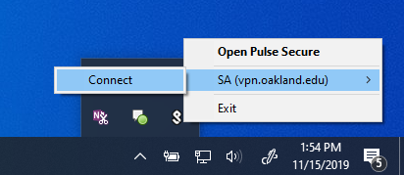

- Login with your NetID and Password
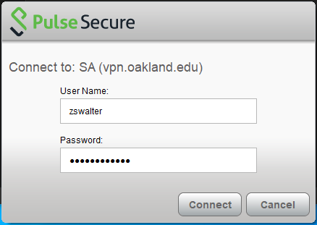

- Open File Explorer

- Right Click on This PC, it is located on the right hand side of File Explorer
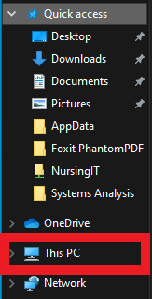

- Click on Map network drive…
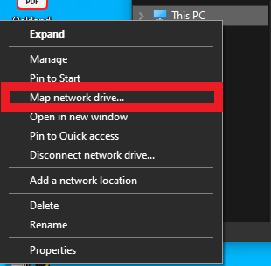

- Choose any drive letter, type in \\shares.oakland.edu\ShareName in the Folder Field, check Reconnect at Sign-in and Connect using different credentials, and click Finish.
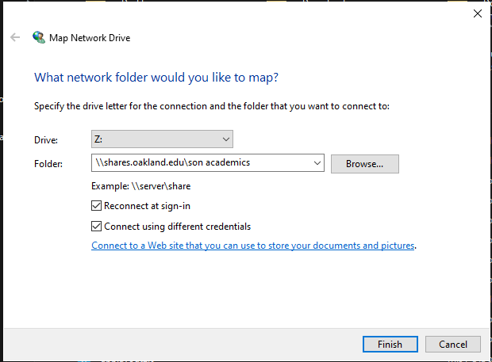
- Type in admnet\your_NetID and your password. Also, check the Remember my credentials box. Click OK.
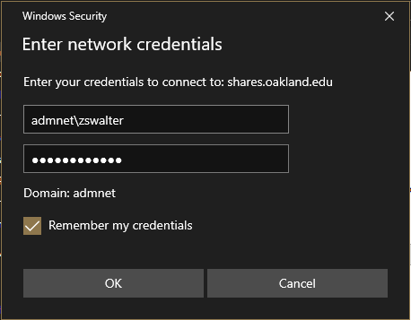

- The share will pop up automatically.
- To find the share open File Explorer
- Click on this PC on the left hand side
- The share will be displayed under Network Locations
