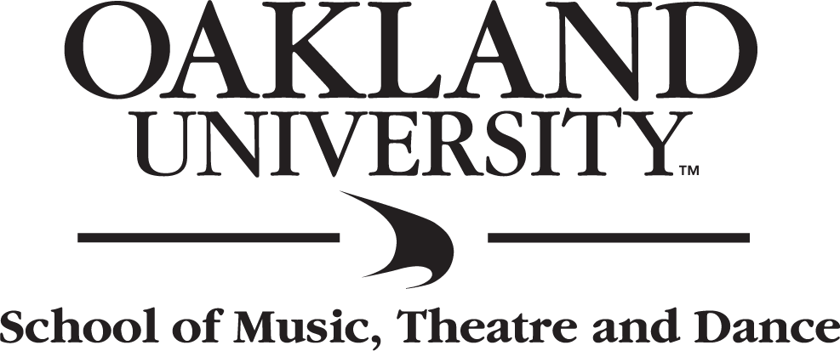

Performer Name
&
Ensemble Name

Assisting Musician Name
&
Assisting Musician Name

Tuesday, November 21, 2017
7:30 PM
Varner Recital Hall
Oakland University

PERFORMER NAME
Instrument / Voice
assisted by
Name, instrument, Name, instrument
from the studio of Professor or Dr. Full Name
- program -
Work Composer
(composer dates)
Work Composer
I. Movement with Number (composer dates)
II. Movement with Number
III. Movement with Number
IV. Movement with Number

Work Composer
(composer dates)
- intermission -
Work Composer
Movement without Number (composer dates)
Movement without Number

Work Composer
(composer dates)

Work Composer
(composer dates)

Thursday, January 11, 2018
7:30 P.M.
Varner Recital Hall

This recital is presented in partial fulfillment of the requirements for the degree of
BACHELOR OF MUSIC IN MUSIC PERFORMANCE

Program Notes

Enter text here:

Food, drink, and smoking are prohibited in the building.
Electronic devices should be turned off or set on silent (no texting).
No recording devices or photography are allowed during the performance and
distribution of this performance, online or otherwise, is prohibited by law.

Late arrivals will be seated at an appropriate break in the program.

Production Staff
Kathy Boersma, Production & Facilities Manager
Megan Herald, Assistant Production & Facilities Manager
Carly Uhrig, Marketing Manager
Terry Herald, Technical Coordinator

Follow School of Music, Theatre and Dance on social media:
Facebook @ OU.MTD
Twitter @OUMTD
Instagram @OUMusicTheatreDance
YouTube @oaklanduniv

SCHOOL OF MUSIC, THEATRE & DANCE
UPCOMING EVENTS

Optional Listing of Upcoming Events

